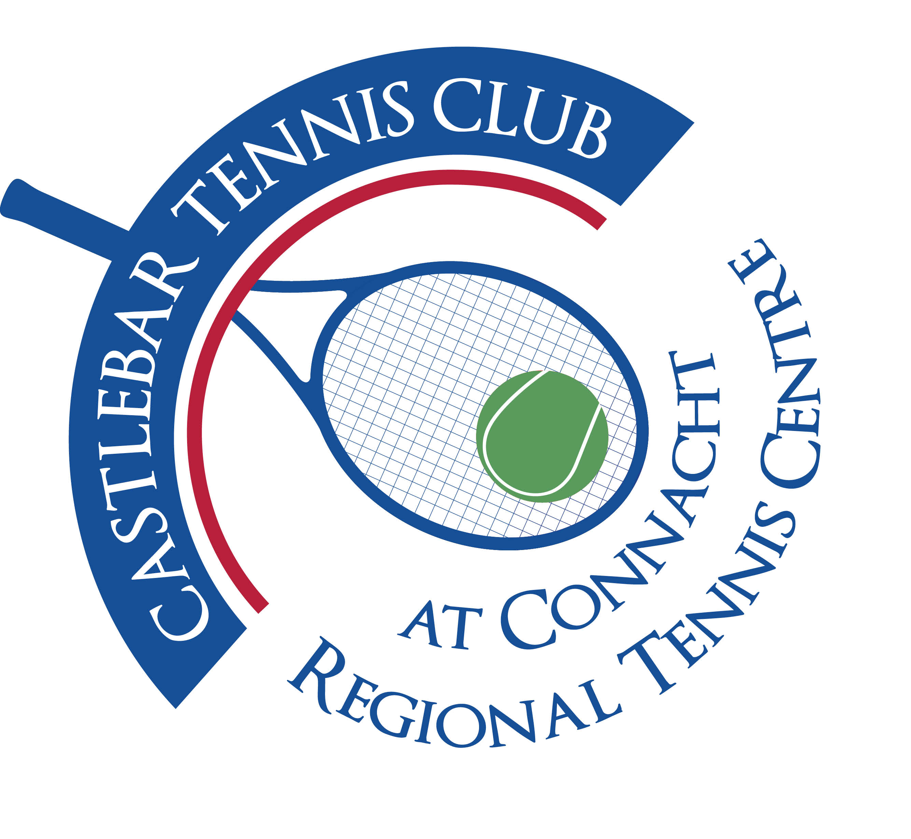

Castlebar Tennis Club

Committee Meeting

MINUTES – 19th October 2023

**--------------------------------------------------------------------------------------------------------------------------**

**Present:** Patrick Quinn, Grainne Cashin, Niamh Kilroy, Emer Dunne , Alma Egan, Tony Mannion, John O’Malley, Neil Ferriter, Jan Frydrych

**Apologies:** James Durkan, Kevin Durcan, Dean Patzer

The purpose of this committee meeting was to discuss festive Draw and Upcoming Tournament Preparations.

* **Tournaments:** Junior Tournament 2nd – 5th Nov: Trophies(retrieve from last year’s winners)-Emer to contact previous winners
* Sponsorship- Rua(Aran McMahon) / Bar One(Mark Cadden)? Give first preference to Aran as to which tournament he may prefer to sponsor-Vets/Junior Halloween Tournament. Also check if Aran would be in a position to cater for the tournament (Niamh to check). We think food i.e.soup & sandwich should be available from 12-4pm on the tournament days-(Junior tournament), plus tea, coffee, bananas, energy bars, brownies,etc. Set up refreshments table in big hall as per August Weekend/ Junior tournament held last June.
* Hall availability – Check with Paul G if big hall is available for the weekend og the Junior Tournament.

**Car Draw:** Draw has gone live online as of this evening(19th October).

1. Need to incentivise members to sell 20 tickets(either online or physical tickets). There will be a draw for anyone who has sold 20 or more tickets. If you sell 40, you’re entered twice,etc. We currently have 180 adult members.

Prizes for sellers draw: 1st prize €500 cash

2nd prize 6 months free membership

3rd prize €150 Tennis Point voucher

1. Need to hit corporates – Patrick will contact Diarmuid & Kevin re same.
2. Garrett/Olwyn – Target tennis clubs across the country using Tennis Ireland database.