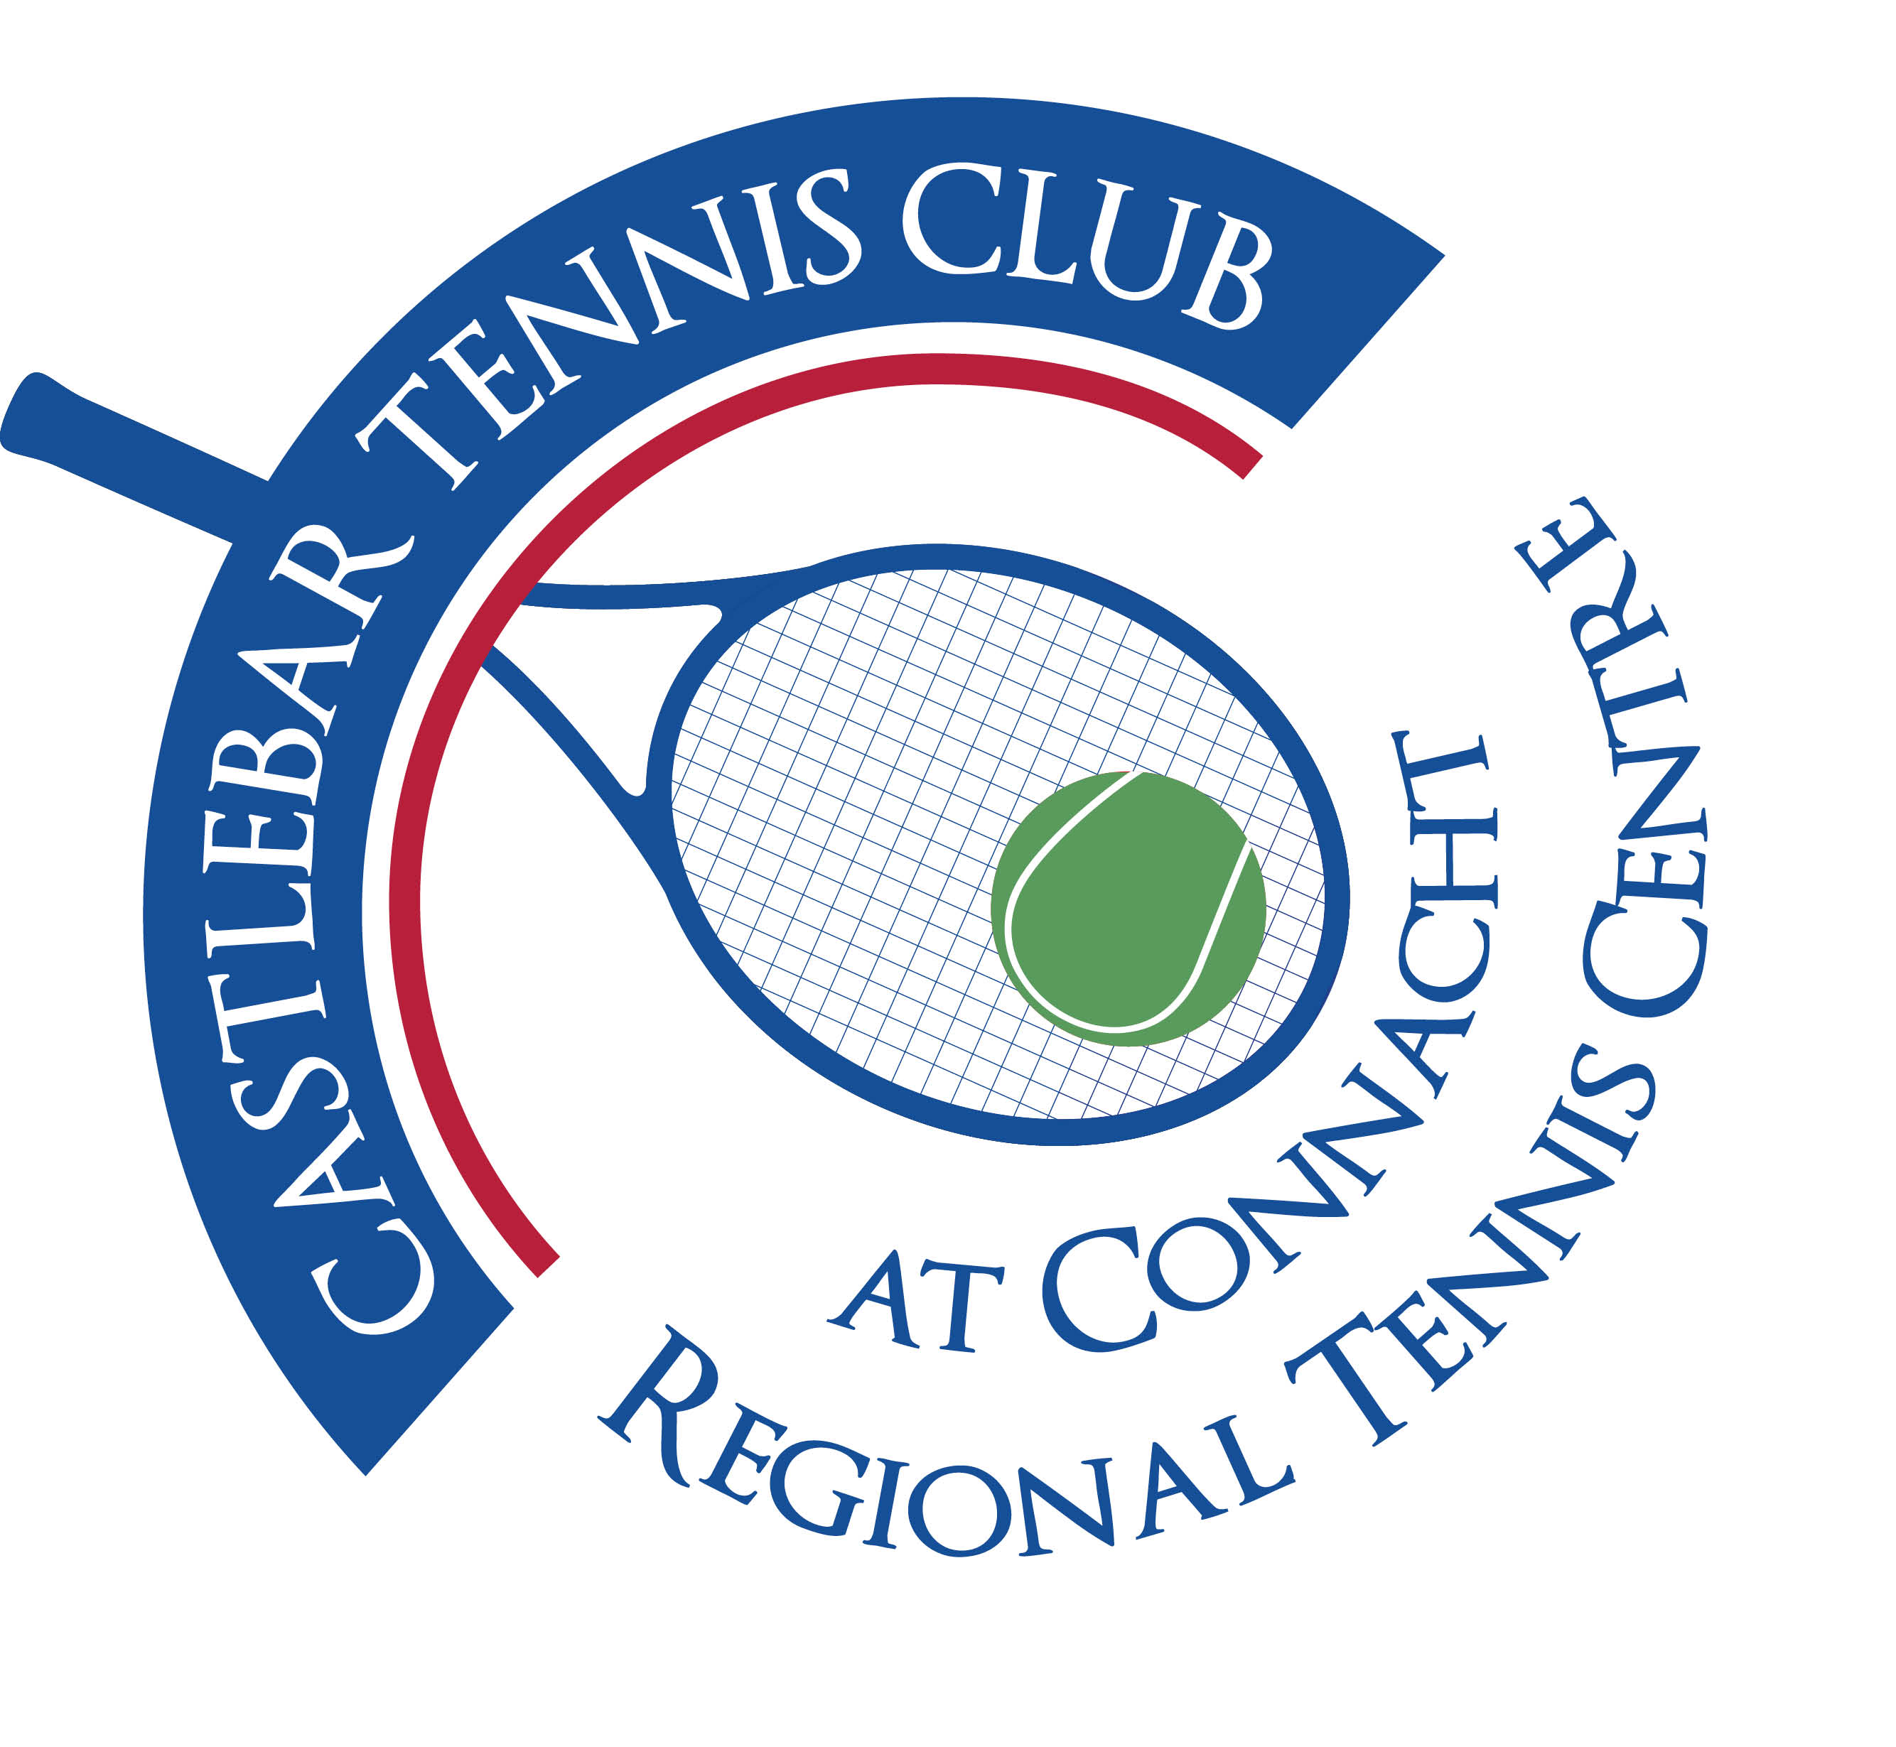

Castlebar Tennis Club

Committee Meeting

MINUTES – 13th July 2023

**--------------------------------------------------------------------------------------------------------------------------**

**Present:** Patrick Quinn, Grainne Cashin, Niamh Kilroy, Emer Dunne , Alma Egan, Tony Mannion

**Apologies:** John Feerick, Kevin Durcan, John O’Malley,

* **Review & adoption of previous minutes –** Proposed by

Seconded by

* **Chairperson’s Update – PQ**

**Car Draw –** In court 21st July, should be straightforward, can go live online from that day. Need new tickets printed(change colour of stub to white). Send email/whatsapp to members to update them and to get money and stubs from tickets already sold back in.

**Wheelchair Access –** John and Donie got quote from Lawless’ for concrete path to side door of dome, railings and small wall - €6k. We should be able to absorb this cost into An Inclusion grant (John F). We would also need an airlock(double doors). Rockland are paid up now. We have a guarantee for the remedial work which was carried out.

**Senior Open –**

**Sponsorship:** Niamh has secured €500 each from Hastings Insurances, Ellison Hotel and Hursts Heating & Plumbing Supplies (€1500 in total so far). Patrick to sponsor also. Tony/Patrick to approach Diarmuid Gavin to see if he might be a co-sponsor. Tom Murphy??

**Bar:** Donie

**Catering:** Emer to ask Anne O’Malley if she’s available to do Bridie’s Kitchen

**BBQ:** Tony to source volunteers to do barbeque. Burger in hand for cpl hours on the Sat. Burgers, sausages, salads & desserts for the Sunday night. Maybe get burgers sponsored?

**Entertainment :** Kevin Durcan to organise (Sunday night only)

**Also:** Need to get trophy back(Shauna Heffernan)

* Whatsapp to members to volunteer for the various jobs(ie catering, bar, making salad/dessert for bbq, etc)
* Jan will need reinforcements to help (Nikol B, Dillon F,etc – they are currently helping with the summer camps)
* Caimin/Costi for restringing
* Scissors lift into dome to fix lights
* Wind breaks from Tennis Point

**Club Manager –** Garrett will be ready to speak to the committee in the next week or so.

**CE Scheme –** We’ve been approved for this. 20 hours a week. Who might we get? Do up a poster with role specifications. Send email/whatsapp out to members to see if they know a suitable person.

* **Treasurer’s Report – NF**
* Finances – We have over €50k in the bank.
* Other- Noreen will be coming on board next year and will be involved in the interim. She is working on a set of management accounts which are almost ready.
* **Secretary’s Report - ED**
* Membership – YTD. 289 paid up members this year. We are on track to take in €57-€59k this year.
* Other – Tennis Ireland webinars (safeguarding and infrastructure). Bernie Caulfield and Patrick to log on to Safeguarding one, James Durcan & John O’Malley? to log on to Infrastructure one.
* **Coaching Report – GB/O’OT**
* **Captains Report – NK/TM**
* Tennis Update – focus is currently on Senior Open
* Doubles ladder to be launched in September
* **PRO Report - GC**
* **Child Protection –**
* **AOB –** We should have a weekly Whatsapp to members with what’s going on/coming up.
* Nadal Presentation – next Tuesday night? (need to contact other prizewinners)
* Whatsapp reminder to members about cancelling courts in good time

**Next committee meeting scheduled for Thursday 27th July at 7.30pm**