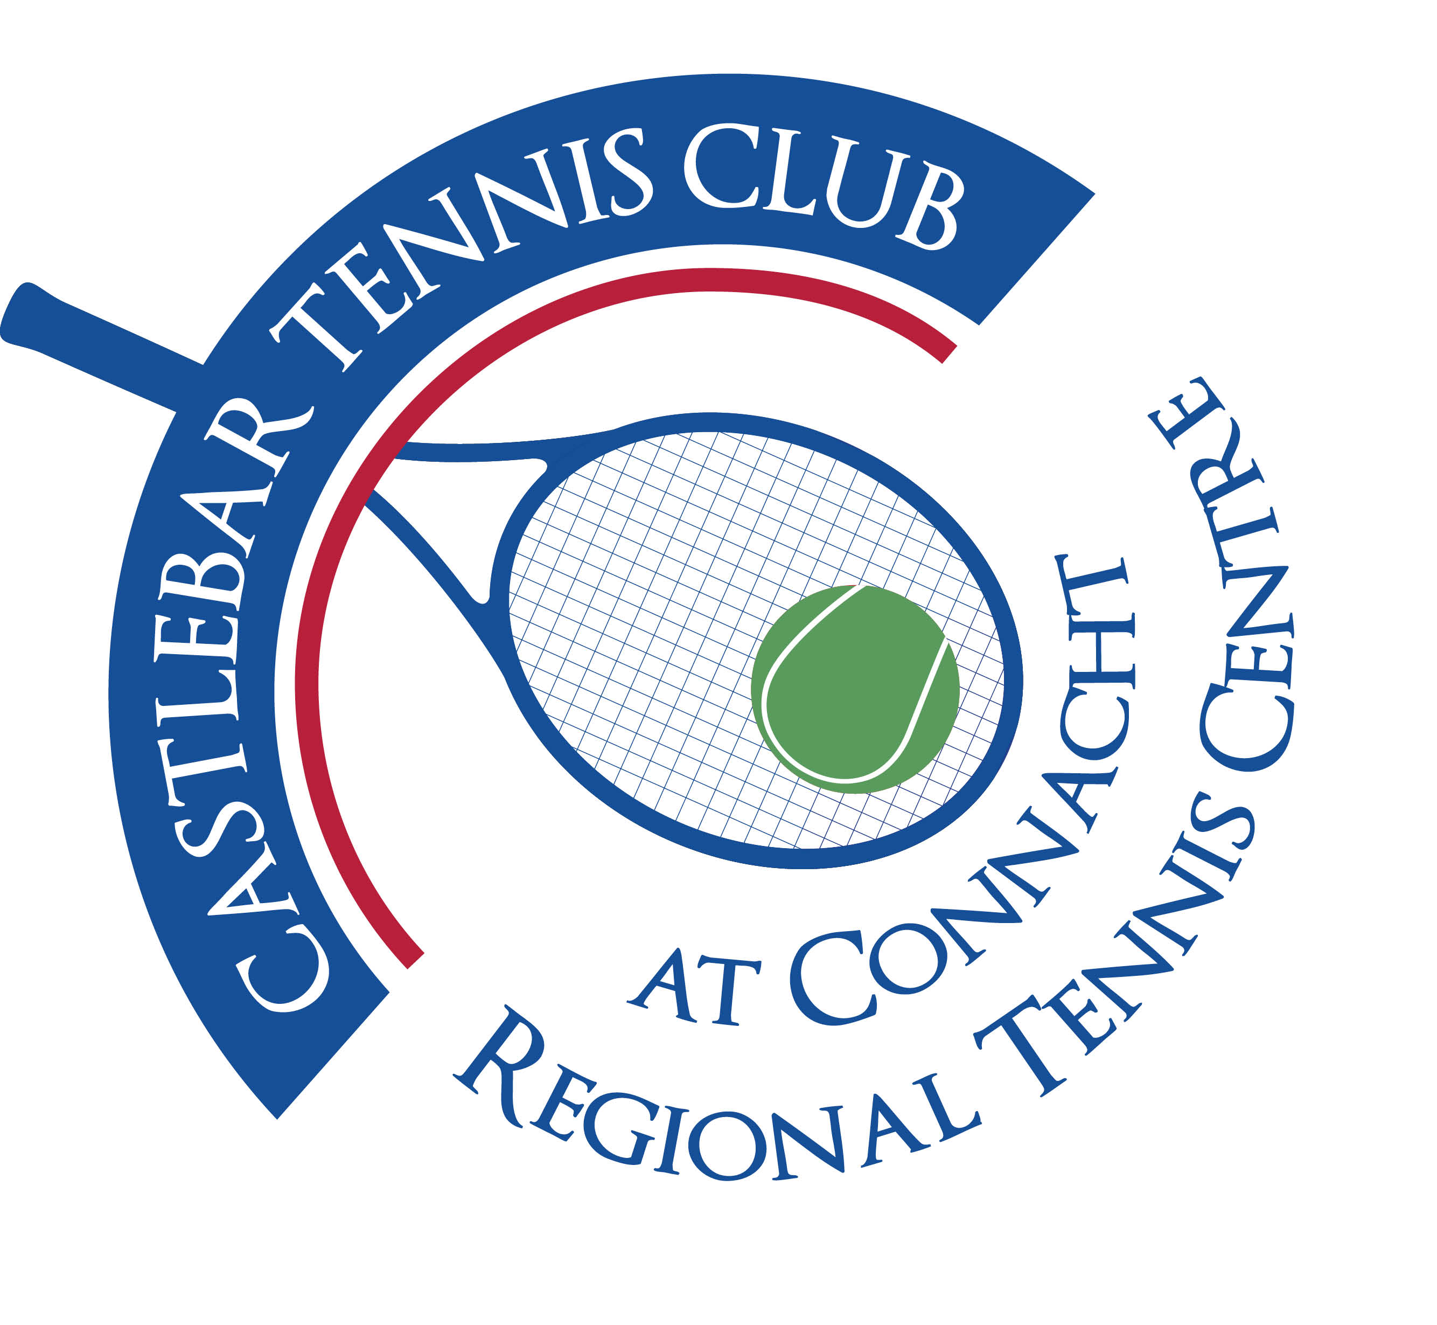

Castlebar Tennis Club

Committee Meeting

MINUTES – 30th April 2024

**--------------------------------------------------------------------------------------------------------------------------**

1. **Present:** Patrick Quinn, Tony Mannion, Grainne Cashin, Alma Egan, Emer Dunne, John Feerick, Paul Meldrum, James Durkan, John O’Malley, Fiona O’Malley

**Apologies:** Noreen McNamee

1. **Chairperson’s Update – PQ**

* **Dome Finance Update –** SCG application submitted was a regional application for €143k(for padel). It will September at the earliest, before we hear if our application has been successful. The amount applied for cannot be changed but we can use any funds allocated to us to go towards a new dome.
  + - According to Alan Dillon ournext best source of funding is the Community Recognition Fund (€50-100k). Need to show how we have catered for Ukranians, blind tennis, social inclusion groups, etc. John F has emailed an expression of interest in this funding on behalf of the club and is waiting on a meeting with David Mellott.
    - Sarah Flood is putting together proposed corporate packages to approach local large businesses with(Abbvie, Baxter,etc)
    - Kevin D and John F to approach other businesses for court sponsorship at €5k per court to cover a 3 year period. Should come to €30k.
    - Clár and Leader funding may also come up.
    - We have €60k ringfenced between savings, GoFundMe, etc ourselves.
    - Our aim should be to have €200k raised ourselves by September, then look for bridging finance to tide us over until the SCG funding hopefully comes through. That way we can have a new dome in place by Autumn.
    - James D to put together a sub-committee to work on a long-term membership package to also get revenue in.
* **Carpark Update –** Would also need to be discussed with David Mellott. Best to leave this for now, the priority would be to see what funding we can possibly get through the Community Recognition Fund.
* **Securing of Club**
* **Coaching Plan –** Sub-committee meeting next week to discuss solution to current situation.
* On a positive note, communication is better, more notice of courts needed for events, more happening by way of adult coaching & clinics,etc.
* We need to find out what’s happening in July – what coaches are staying on,etc Do we need to pay someone to come in and do the admin of will one of the coaches do it?(Daniel?). We need to have this sorted by the end of May.

1. **Treasurer’s Report - NMcN**

* Finances – State of play
* Other – What were the final figures on the OsKars & the Car Draw? It would be good to know exactly what money we made.

1. **Secretary’s Report - ED**

* Membership 190 members have renewed
* Other

1. **Coaching Report – GB/O’OT**
2. **Captains Report – GC/JD**

* **Tennis Update** – Spring League currently running. Finals Night 17th April, have a BBQ and include as many members as possible on the night.
* Singles Ladder to be run after spring league (no entry fee for members – give back!)
* Couch to court (8 in the group) currently running
* Improvers lessons currently running
* Return to Tennis (group of 6) currently running

1. **PRO Report - GC**
2. **Child Protection – BC**

Details were read from a report of an accident involving a 5 year old child who got his arm trapped in the revolving door while exiting from the courts after a tennis camp. No injuries/damage was sustained in the incident. The fire brigade was called by Olwyn and they had to free the child’s arm from the door. Ambulance also arrived. We should expect an invoice from emergency services.

1. **AOB**

* **Court Lights –** still need attention, cherry picker needed to replace bulbs, can’t have sub-standard lighting especially for August weekend when matches go on until 11/12 at night.
* **Need committee members to take on the following areas: Bar and also kitchen and catering/food for events during year**
* **Car Charging point –** 2 spaces, power can be brought around. Gary Corbett sent on details to John O’Malley(which have been forwarded on to the committee for consideration since this meeting). It would appear to be a no-lose situation for the club!
* **Coffee van:** Colin Kinsella (partner of Laura Scriney) has a coffee van and is looking for a pitch. Patrick was speaking with him. Would our car-park be suitable? He would pay a fee to the club. Covered by insurance? He is to trial it (at weekends I think was mentioned?)

**Next Committee meeting is scheduled for Tuesday May 28th at 7pm.**