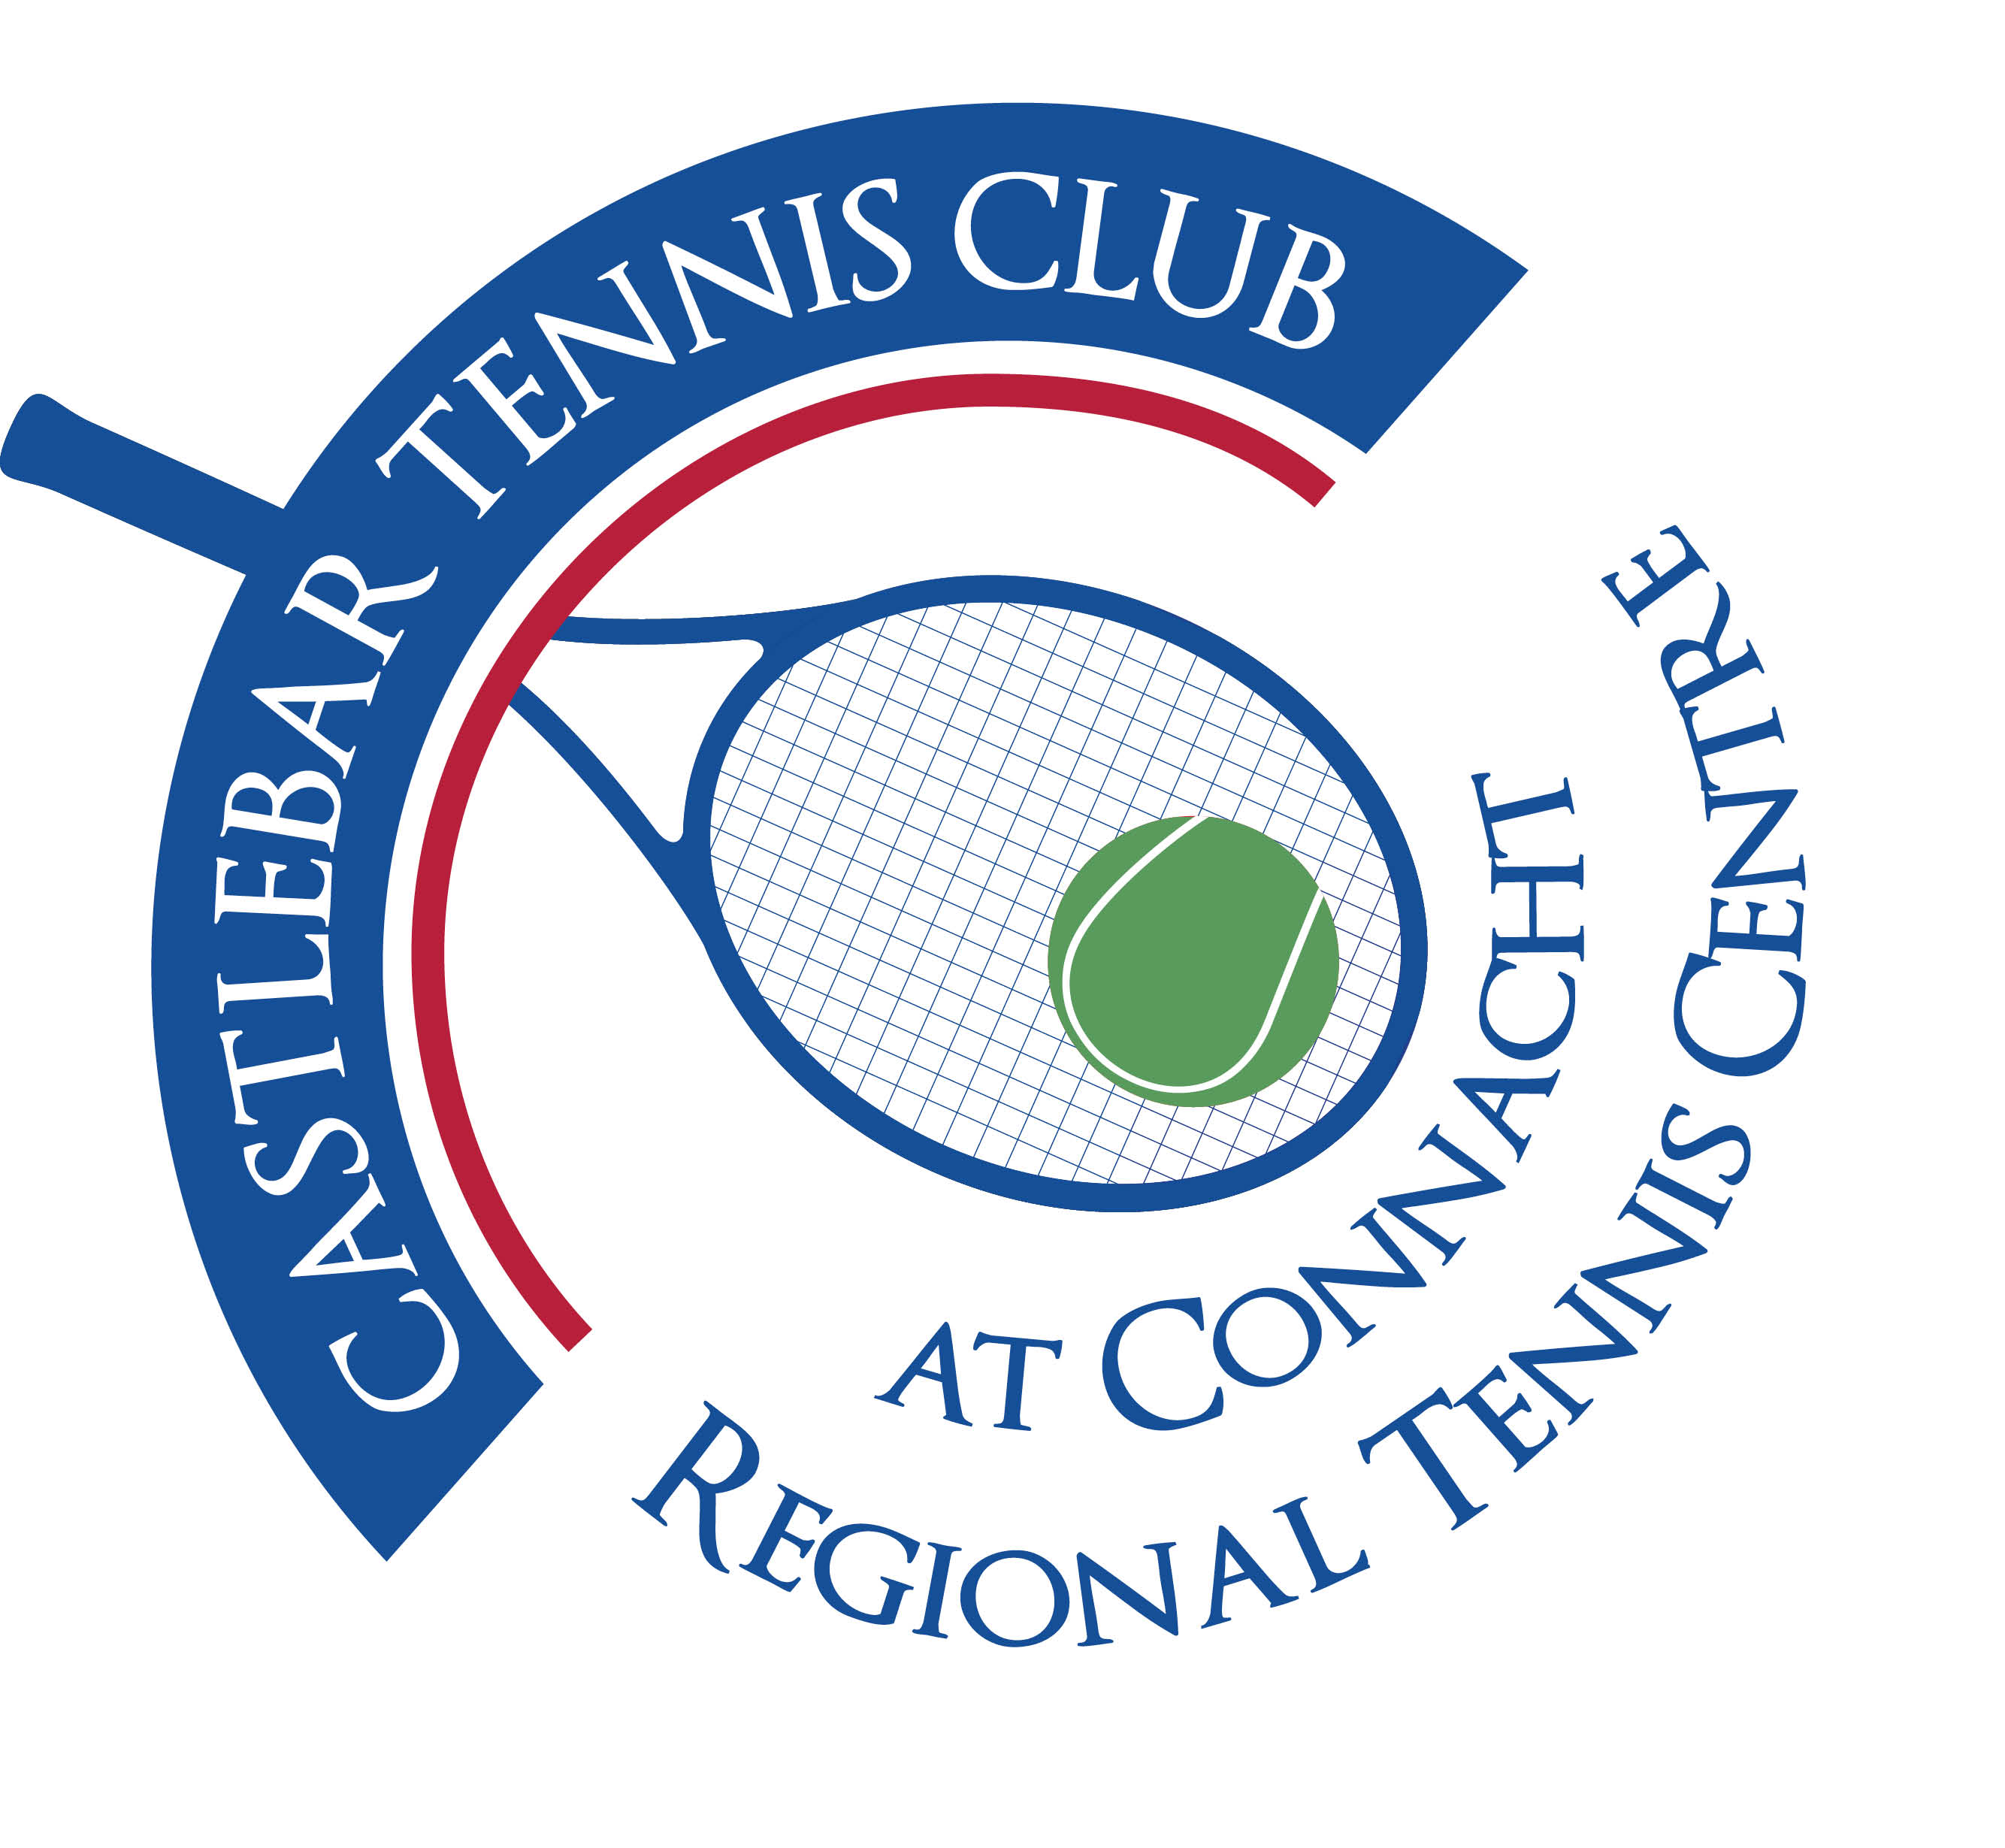

Castlebar Tennis Club

Committee Meeting

MINUTES – 30th January 2024

**--------------------------------------------------------------------------------------------------------------------------**

**Present:** John O’Malley, Alma Egan, Niamh Kilroy, Paul Meldrum, John Feerick, James Durkan, Tony Mannion, Patrick Quinn, Emer Dunne

**Agenda items for discussion:**

1. **Dome update**
2. **Dome quotes and Suppliers**

* We don’t have any quotes as of yet.
* Patrick will talk to Gert (manager in Bekan).
* Do we need a professional with us when we meet with the dome suppliers?
* All-in-all the project will be around 350k.

1. **Covering possibilities**

* Should we look only at dome options or go for a roofed structure with retractable sides?
* 3rd Generation dome?(like in Bekan). It doesn’t get too hot or too cold.
* L-shaped dome?
* Probably better to go with 2 domes(4 court + 2 court), but pricing?
* We need to get quotes for both options.

1. **Funding Strategy, including GoFundMe, government funding, etc**

* GoFundMe has stalled a little, need to get it going again-newspapers need to be touched and pushed out more on social media.
* Sarah Flood will put signs out on the road. John Feerick will get a press release out to papers by Saturday.
* Tommy Marron (Midwest)could give a mention(and focus on social inclusion aspect).
* Pat Jennings (TF) has given his theatre free of charge for us to hold a fundraiser. Possible acts: The Saw Doctors, Tumbling Paddies, Daniel O’Donnell, Hothouse Flowers??
* Patrick was speaking to Ollie Jennings (manager of The Saw Doctors)about hiring them for a gig in the TF. They would sell-out. Saw Doctors fee would be €60k. If we charged €35 per ticket we could stand to make in or around the region of €40k. If agreed, It probably wouldn’t take place until late this year/early next year.
* Seating: Clár funding perfect for seating. Has to be for a completely separate project, not tied in with anything else.
* Leader funding better for social inclusion(wheelchair accessibility, ramps,etc)
* Community and Voluntary Grant coming up (Mayo CoCo, up to 7k) – need to apply for a specific thing e.g.lights
* GMA funding application to be submitted by this Friday 2nd Feb.(Alma/James). We need to approach as many Councillors as possible to secure funds from them! John F to circulate a message re same to members.
* Paul G wondered could we sell some of our unused land?
* Kevin Kelly – meet him/have exploratory talks? (Patrick/John F)
* Kevin Quinn (CEO Tennis Ireland) will be at the club for a meeting on Thursday 15th Feb. Would be good if a few were around to meet him. Hopefully he can also help us.
* Sports Capital Grant: Once allocation has been made we can change what we use the funds for(in these exceptional circumstances).
* **N.B.** Going forward all grant applications should go from and come back to the Treasurer.

**Additional funding ideas :**

* 2 Six Nations Tickets for Ireland v Wales home game in the Aviva on 24th February have been donated by Des Murphy (Director of Mountain View Securities). John F to contact Tommy Marron(Midwest) to see if he will do an on-air raffle to push the tickets.(John F)
* Multiyear membership – buy a few years membership at the one time for a discounted price. Will get money in! Might have to cap it. (James)
* Golf Scramble (Tony)
* Table quiz with Tony Stakelum/Adrian Keena/Patrick as quizmaster?(Kevin)

1. **Current enhancements**
2. **AGM Plan**

* AGM is set for Tuesday 6th Feb at 7pm
* Timeframe for when courts will be covered again – end of Summer/early Autumn!

1. **AOB**

* Social night for members – Fri 9th/Sat 10th Feb. Tennis and food in hall afterwards. Bbq? A thank you for the clean-up. Also to keep the positivity/momentum going. Mars bars & bar credit as prizes?
* Some discussion has been had(with Sue Baird) as to whether or not we should change to a limited company. The feeling currently is that we are better off as we are.
* Tennis Ireland is working on affordable insurance for tennis clubs.
* **Paul Gavin** – we need to put a plan in place. He is doing too much and can’t keep going. Also suggested that we have a President’s night for him!

**Forgot to mention:** Bobby Kerr(Newstalk) broadcasting from Hub behind ATU this Saturday 3rd Feb. Have contacts there, hoping to get a mention about the dome on his programme!