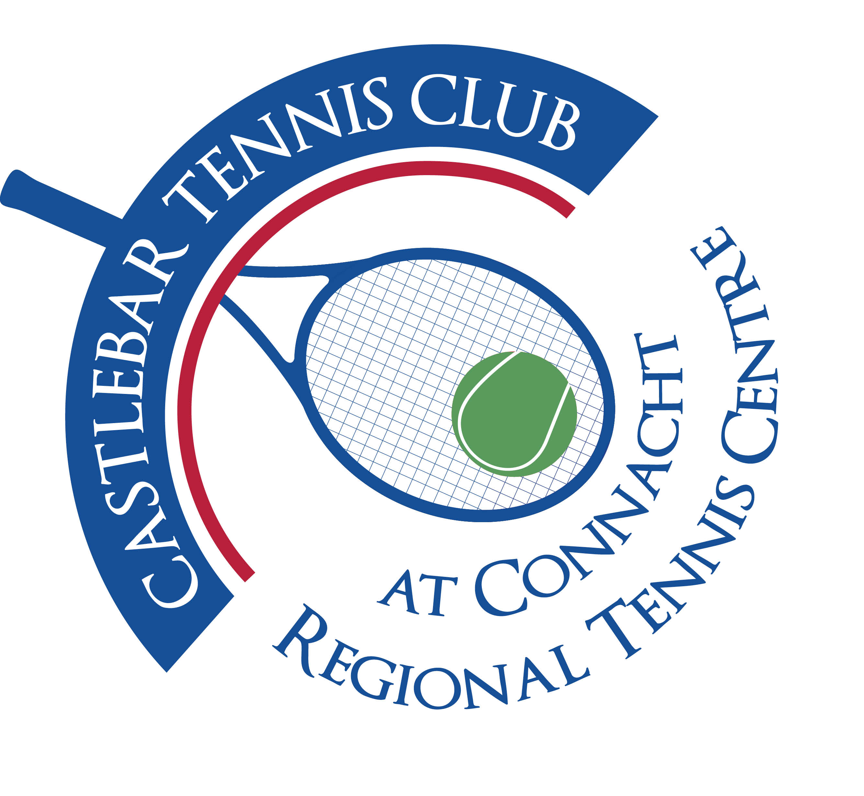

Castlebar Tennis Club

Committee Meeting

MINUTES – 29th August 2024

**Present:** Patrick Quinn, Noreen McNamee, Grainne Cashin, Paul Meldrum, Emer Dunne, Alma Egan, Kevin Durcan, John Feerick, James Durkan

**Apologies:** Niamh Kilroy, Fiona O’Malley, Tony Mannion

1. **Review & adoption of previous minutes –** Proposed by

Seconded by

1. **Chairperson’s Update – PQ**

* **Dome update/potential supplier –** Cost will be approx €300k. Prunty (Bekan) and Rocklyn are cheapest, leaning towards Prunty, Rocklyn’s aftercare not good.

With approximately: €65 in bank plus €100 SCG(hopefully), that leaves shortfall of **€135k** to cover cost of new dome.

Court sponsorship of €30k plus possibly €50k from new carpark agreement would cover a good portion of that shortfall.

* **Fundraising Dome** – 1) **Community Recognition Fund** hasn’t been successful. David Mellott has given the reason for this is that the application hadn’t been made through portal (we had put application through him personally as he had suggested!). We had included everything that he had asked for in the application. We think it had already been decided to allocate the funds elsewhere. There is another window for applications in November (portion of funds is held back from projects that didn’t go ahead,etc), with word coming through in February. We may get some funding then.

1. **Sports Capital Grant -**  max we can get is €137k
2. **Car-park –** this agreement is up in December. David Mellott is also over this. We could ask for 50k?
3. **Credit Union –** We have put in for €10k, still waiting to hear back.
4. **Corporate Sponsorship -** €5k per court(€30k total). Give staff members reduced membership rates on sliding scale e.g. Year 1-25% off, Year 2-15%, Year 3-10% etc. Sarah Flood has done up sample letter to approach potential sponsors with.
5. **Savings -** We have approx. €60k in bank of our own to use.
6. **Bank –** bridging finance? We have arrears of €38k-we would need to clear that first. Talk to banks and also to Credit Union. Noreen and Patrick to meet the bank in next 2 weeks, by end of September we’ll know about SCG, then we’ll know what the shortfall is. Trustees would need to be contacted as would need to sign off on any additional borrowings.

* Email to members at end of September(after we hear about SCG) with an in-depth update on dome. As a gesture of goodwill we may extend all members renewal date by 2 months.
* **August Weekend recap**

1. **Treasurer’s Report - NMcN**

* Finances – All figures are approximate: Main a/c €22k

Bar a/c € 1,367

Membership a/c €10k

Dome a/c €64k

* Other

1. **Secretary’s Report - ED**

* Membership
* Other

1. **Captains Report – GC/JD**

* Ladder is finishing up shortly. Will have finals night.
* Coaching(both Junior and Adult) resuming week Monday 9th Sept.
* Club Championships will probably take place in October.
* Few Fun Fridays planned.
* Vets due to take place in November.
* Ball machine back working!!

1. **PRO Report - GC**
2. **Child Protection – BC**
3. **AOB**

* Young Senior Inter-pros- we are co-hosts with Westport and Claremorris. Friday 13th and Saturday 14th September. Carra catering will do food. Need volunteers to help set up big hall Thursday 12th evening.
* EV charger point
* Petanque – Possibility of having Connacht Petanque at Castlebar Tennis Club. Gravel pit to the RHS as you drive in gates of club. How would it benefit the club? Mostly retirees that play, 11am or thereabouts. Charge pavilion membership, therefore players will be covered by club insurance.
* Lights – Donie to check price for an over-ride button

**Next committee meeting scheduled for Thursday 3rd October at 7pm.**