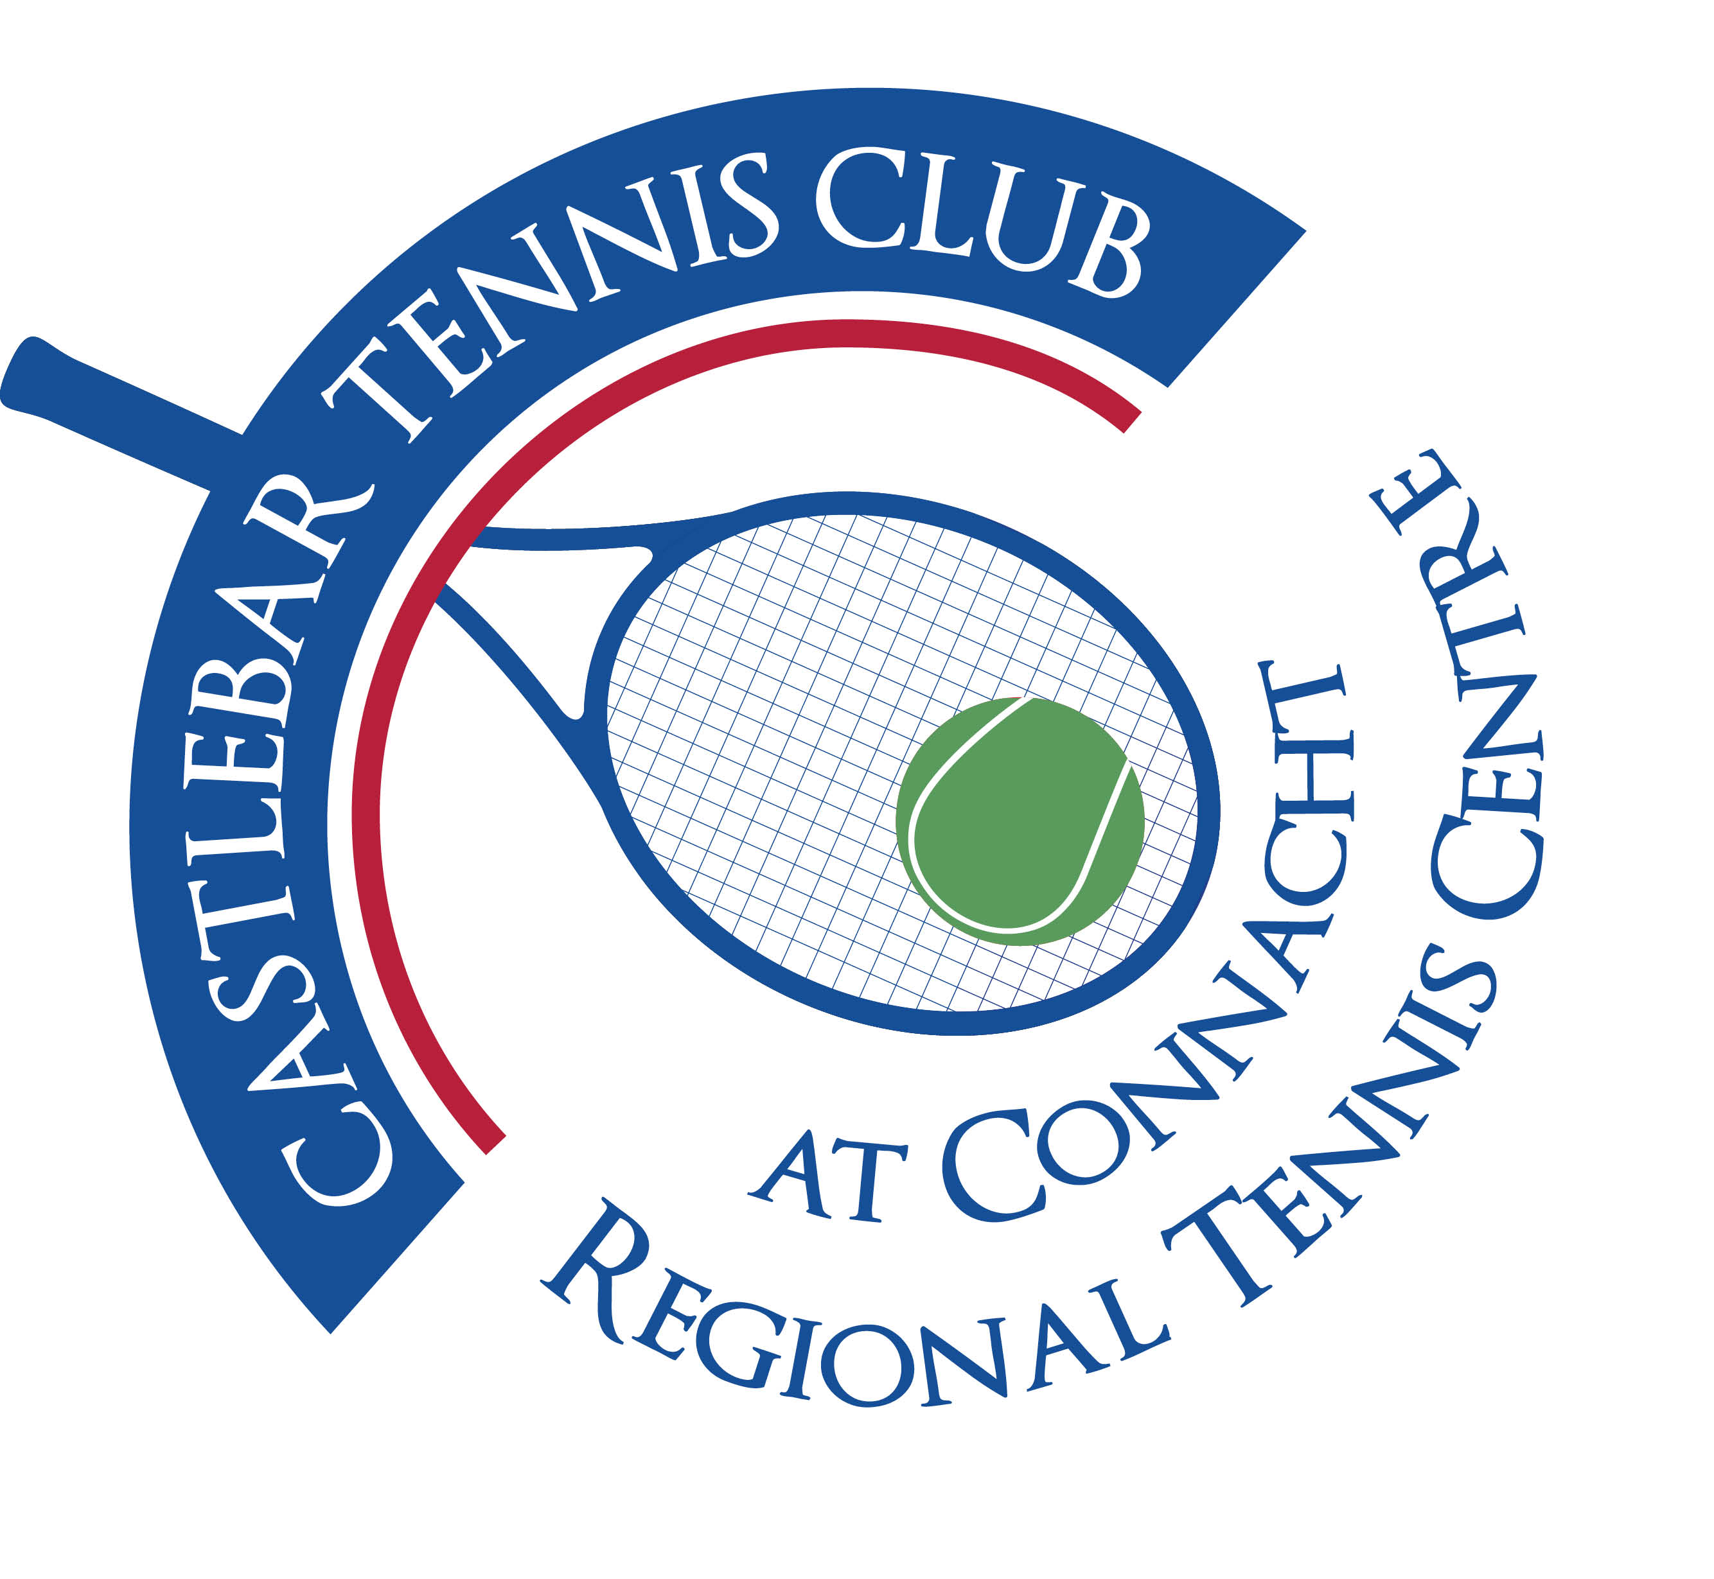

Castlebar Tennis Club

Committee Meeting

AGENDA – 29th May 2024

**Present:** Paul Meldrum, Tony Mannion, Grainne Cashin, John Feerick, Noreen McNamee, John O’Malley, Alma Egan, Kevin Durcan, Emer Dunne

**Apologies:** Patrick Quinn, Niamh Kilroy

1. **Review & adoption of previous minutes –** Proposed by Alma Egan

Seconded by Tony Mannion

1. **Chairperson’s Update – PQ**

* **Coaching agreement update(After meeting with coaches earlier in the day)**

Grainne and James met with Garrett. Main points as follows:

* Olwyn stepping away. She has formed own company(Access Sport Foundation).
* Garrett proposes to stay on to co-ordinate Adult and Junior coaching. Daniel and Jan to be the on-court coaches. They will cover all coaching groups including outreach, blind tennis,etc.
* Percentage to club is currently 10%. This should be revised when there is a review carried out(after 6 months?). There needs to be much more communication/feedback than there has been previously(ie reports for committee meetings). Grainne and James to be the points of contact with Garrett.
* First issues to be sorted are summer camps and adult coaching(couch to court/beginners,etc)to be run in July/August by Jan.
* Olywn applied for a grant to cater for IPC(international protection groups). Got 10k in funding. Will pay a coach to run a multisports camp(must be multisports-tennis plus 1 other sport). Dylan the strength & conditioning coach would be qualified to cover the ‘other sport’ part of the camp. Places would be reserved for IPC children and the rest available for local children to book.
* Overall feeling coming away from the meeting was a positive one.
* Grainne to get back to Garrett to let him know we will go ahead.
* **Dome Financing Update**
* John, James and Kevin had a very positive meeting with David Mellett re Community Recognition Fund. They want to fund one big project rather than a few smaller ones. Want a sporting hub at Lough Lannagh.
* We need to show that we are working with various groups in the community such as Ukranians, blind tennis,etc. Also our hall has a number of church services on a weekly basis, card games, dance classes,etc. We also run camps, have schools in. This all shows that we are a community club catering for a wide range of groups.
* We should look for 250k. Noreen, James & John to have a meeting to put it all together and submit it by end of June.
* John F spoke with a guy from Mayo Sports partnership about the possibility of having French Boules on part of our grass area. There’s 5k available for this. It would preferably be behind courts 3-6 in case we go ahead with padel in the future. This would bring a new cohort of people through the gates of the club. It’s a very popular sport in Spain. The President of the Connacht Boules Association is to come to the club to meet committee members.
* Kevin, Sarah and John to have an online meeting about court sponsorship.
* **Junior Tournament 21st-23rd June**
* Grainne to liaise with Emer. Casey’s normally sponsor €500. Last year Breaffy House did also. Maybe one sponsor is enough? Save Breaffy House for a different tournament/event? Need to sort catering & rota for tuckshop. Last year we did bbq-free burger for each competitor, everyone else pays €5 per burger.
* **Dome Quote Update(Time to Make Decision?)**
* Quotation in from Prunty Contracts. They put up the dome in Bekan. Very competitive price. 227k plus VAT, which would include new blowers, new door which would allow for wheelchair and maintenance access. 20 year warranty for the membrane, 40 year life expectancy. 12 weeks from placing an order to installation.

1. **Treasurer’s Report - NMcN**

* **Finances**

Noreen noted that a bridging loan could prove difficult to secure as we are in arrears with the bank from covid.

IMRO €900 bill due(2 years). Noreen to set up monthly payments from now on instead. This must be paid to have tv/music,etc on in the club.

Tennis Ireland energy grant has been announced. We send in our ESB bills and hopefully will get some money back.

John mentioned Credit Union Community Fund - Anyone have a contact there??

Climate Action Fund – We should apply for this next year(panels on roof,etc)

1. **Secretary’s Report - ED**

* **Membership** – some members who haven’t yet renewed are playing(just not booking courts). Emer to send out email to remind members that you must pay if you wish to play!
* Also need to ensure that everyone in receipt of coaching is a fully paid up member. Should we display a list of currently paid up members on the noticeboard.
* Paul suggested a display monitor with important messages/upcoming events. Could be inside the window of front office-get people’s attention, many don’t read the outdoor noticeboard that is already there.
* **Other** – Insurance due for renewal beginning of July

1. **Captains Report – GC/JD**

* **Tennis Update**
* Fun Friday 14th June & Summer Bbq. Entry fee to cover prizes-€10 for burger & pint?
* Ladder also starting soon(to incorporate grading of players, then coaching to suit various grades 3,4 etc)
* Fun Friday for Cliff Liverpool in September
* Aug Weekend – we should have a raffle in aid of our new dome

1. **PRO Report - GC**
2. **Child Protection – BC**

* Nothing to report

1. **AOB**

* **Bar Training –** Paul to chat to Donie about training. **Update:** Donie happy to do training. Date & time to be decided, then a message will go out to members for anyone that is interested.
* **Kitchen and catering/food for events during year**
* **EV Charger –** Most of our concerns addressed. Need to get solicitor to look over it and in case Trustees need to sign anything. It seems like a no-cost, win-win situation for the club.

**Next meeting is TBC.**