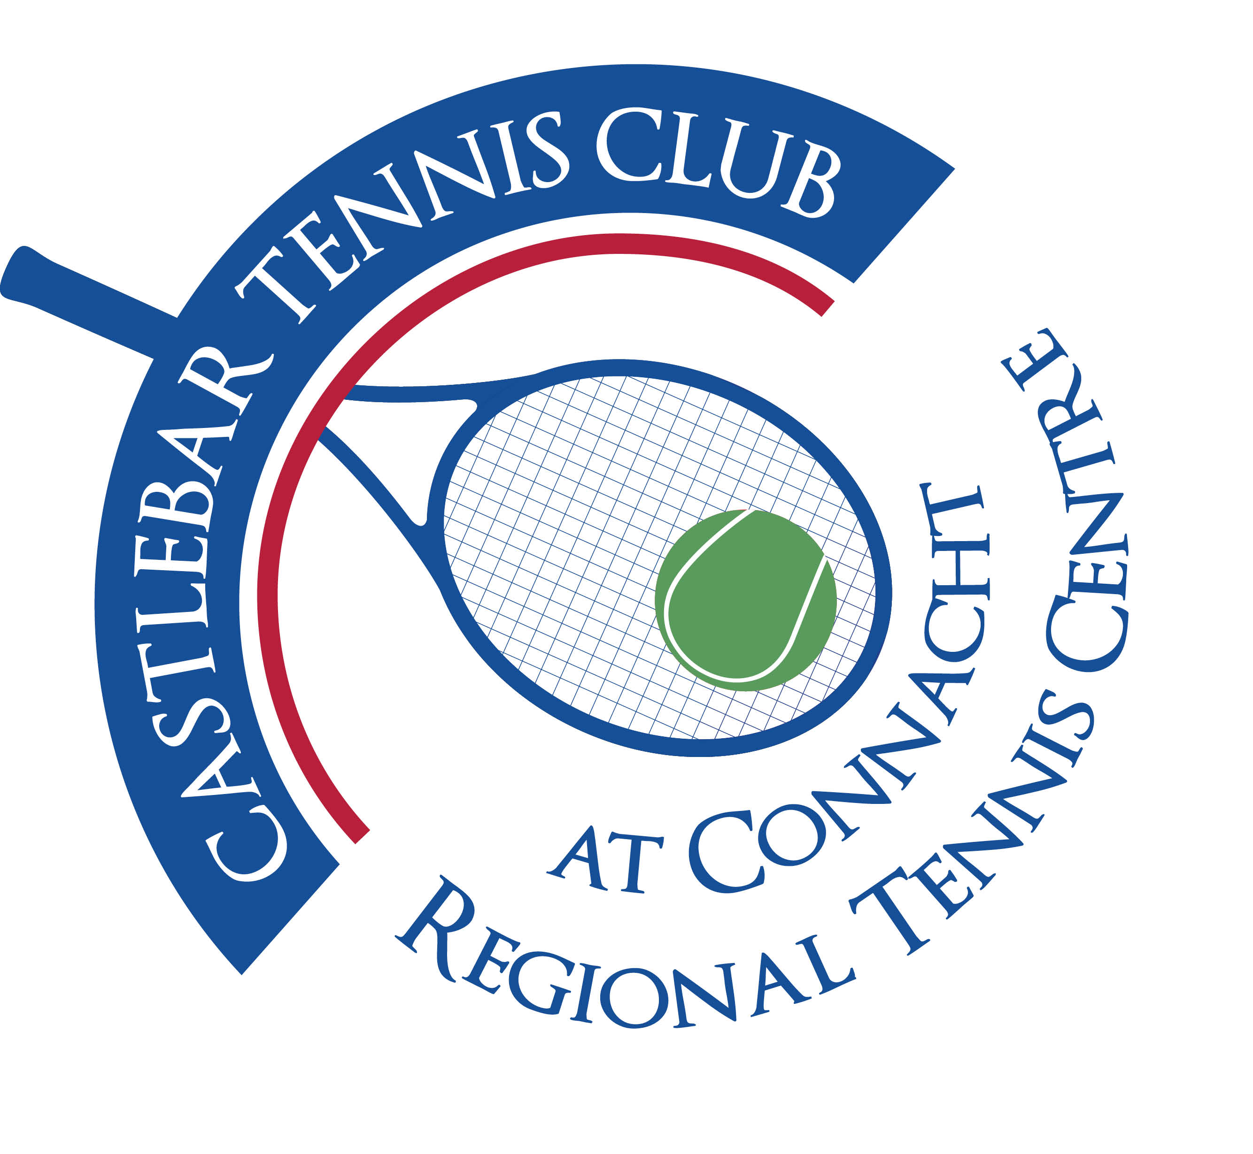

Castlebar Tennis Club

Committee Meeting

MINUTES – 29th February 2024

**--------------------------------------------------------------------------------------------------------------------------**

**Present:** Paul Meldrum, Grainne Cashin, Patrick Quinn, John O’Malley, Kevin Durcan, James Durkan, John Feerick, Alma Egan, Niamh Kilroy, Fiona O’Malley, Noreen McNamee, Emer Dunne

**Apologies:** Tony Mannion

* **Dome Cover (Alma Egan):**

Everyone is going for **3rd Generation** domes these days (our previous dome was 2nd Generation).

**Dome companies contacted to date:**

1. **Duol** (Peter Herbert) - Rolls Royce of domes, have installed for David Lloyd Clubs in the UK. Met with Alma, John O’M & Donie at the club on 20th Feb, very impressive, provided membrane samples, brochure, 2 hr meet & site inspection(what could be re-used, etc), took measurements. Will update dome committee on progress re quotes (should have an estimate by next week) and communicate collated data with committee. Looking at a 4 court dome, not dog-leg(4 dome +2 dome would be cheaper).
2. **Covair** (Ben Stevenson) – Ben previously worked for Rocklyn when our original dome was being installed, not a great relationship there!
3. **Bridome** – Have installed domes for Donnybrook & Fitzwilliam Tennis Clubs, could do a transparent viewing panel along the side of the dome.
4. **PSTSport** (Kieran Donaghy) – They will be back with a quote in 5 days(from date of meeting). They will also visit the club (& are also looking at Galway TC).
5. **Sportsfacilitiesgroup**
6. **Rocklyn –** installed our previous dome
7. **Broadwell Airdomes (US company) –** quotation was 1/3 of every other company! Lights are extra, would customs charges apply?

**JayPee** (John Hogan, Ballaghaderreen) – emailed the club with a more permanent type of roofing fixture that may suit our needs? Should we look at his idea??

* We Need a **Dome Committee** – Alma to lead it and recruit people who are around and available for site meetings during the day,etc
* We are looking ballpark at 280/300k minimum for 4 court dome.
* Patrick - What about pushing out the ring-beam to include a seating area?
* Fiona - We need to get a tender document – with our brief on what we want pricing for,etc. Also check for customs charges from UK (in case these would be hidden costs that we wouldn’t have budgeted for).
* James - We need a shortlist of 3 companies, get quotations from all 3, then we’ll know how much money we will need for the project.
* **Chairperson’s Update – PQ**

**Existing lighting:**

It would cost 7.5/8k to change lights on clay courts to LEDs. Waste of money as these lights aren’t used when the courts are covered. Also it’s staying brighter for longer now, clocks will go forward soon,etc. We already have spare bulbs to put into lights that aren’t working, just waiting on a hoist.

* **Treasurer’s Report - NMcN**
* **Finances :**

Bank:

Main a/c €17k

Bar a/c € 2k

Membership a/c € 8k

Savings a/c €26k

Gofundme money (approx currently €37k) is still in the gfm a/c not in the bank yet, we have until 23rd May to draw it down. It will go into savings a/c.

* **Other :**
* Q-How much do we have to raise ourselves?
* John F asked Alan Dillon if we could revise our **SCG** application to the full amount (€200k)? Yes we can, but there’s no guarantee that will get that amount. The local allocation should be out in April. Should we change to a regional application seeing as the application will now be for a dome, not padel?
* Emergency funding from Government really will be Sports Capital Funding under a different guise. John F got a letter from Thomas Byrne(Minister for Sport and Physical Education) sending apologies about the dome, stating that Sports Capital is the way to go.
* We have €50k (Gfm and savings), if we get €200k from SCG = €250k. We can make up shortfall through grants/long-term(10 year) memberships,etc. We are still due €5k from a grant. We need to find corporate sponsors(naming rights/name the dome after them).
* We don’t want to touch our mortgage until arrears are sorted.
* We need a funding sub-committee – John F, Noreen McN, Kevin D.
* TBSS Grant – energy saving grant from the Government – we should apply for this!
* Pat Jennings (TF) has given us the use of his theatre free of charge! Kevin Rowe rang Noreen to see if we would like to do a fundraiser(casino night maybe?). Pat also gave 4 tickets to Jason Byrne for this Saturday night.
* **Secretary’s Report - ED**
* Membership
* Other
* **Coaching Report – GB/O’OT**
* **Captains Report – GC/JD**

**Captains Plan 2024:**

* Had Spring Social 9th Feb, 18 players.
* 1 team entered into phase 2 of Connacht league.
* Coaching Clinics by Daniel [first date TBC]. Hopefully run 1 a month for next 4

months then possible break for July and August.

* As goodwill at this time and aim to retain members - No entry fee for any Social

nights.

* Sponsors that previously would have sponsored small amounts for Fun Fridays – we

will wait and target them for any fundraiser.

* March – Easter Night on Good Friday 29 th March.
* April – Start a spring League. Run over 6 weeks.
* Nadal ladder 2024 – prize is funded by entry so may not be possible as interest may

not be as high to have week in Nadal academy -looking at alternative prizes . Run

over a number of months. May poll the members to gauge interest.

* Will trial Ladies Doubles night – Thursdays and Mixed Doubles night – Fridays. 3

courts 12 people.

* Couch to Court – Olwyn hoping to start on March 11 th – 5 week program for men and women. Sign up for 2 month membership 50 euros. James and Grainne will liase with
* Olwyn towards end to incorporate members into club.
* **Junior Captain 2024:**
* Eoghan Jennings
* Juniors v Adults fun competition.
* **PRO Report – GC**

Not covered

* **Child Protection – BC**

No issues to report

* **AOB**
* **Communication to Members and Trustees:**

Monthly email to all members – membership/tournaments, information,etc

* **Coaching Team :**

We need a committee member liaising with the coaching team (Tony M).

Need more communication abpout coaching team (who are the coaches? What coaching they do – groups/individual,etc)

For review June 2024 when both Garrett and Olwyn are leaving. Contract for review – to include all T&C’s. Need a Head Coach. Recreational coaching?

10% to club from coaching, private lessons own earnings.

* **Access and lock-up (in preparation for Paul’s absence) –** Are we going with a Club Manager position? We could get funding through CE (Community Employment) Scheme.
* John F asked if thank you letters had gone to councillors for their funding to date – yes they have been sent (Emer). GMA funding for this year from councillors still for allocation.
* **Padel** – withdraw planning (James D to do so).
* **Need committee members to take on the following areas: Bar/vending machine, Kitchen and catering/food for events during the year –** not covered
* **13th/14th September 2024 –** Young Senior Vets Interpros to be held. Hosted by Castlebar/Westport/Claremorris. (Castlebar as the main centre).

**Next Committee meeting will be held on Thursday 21st March at 7pm.**

**Kind regards,**

**Emer Dunne**

**Club Secretary**