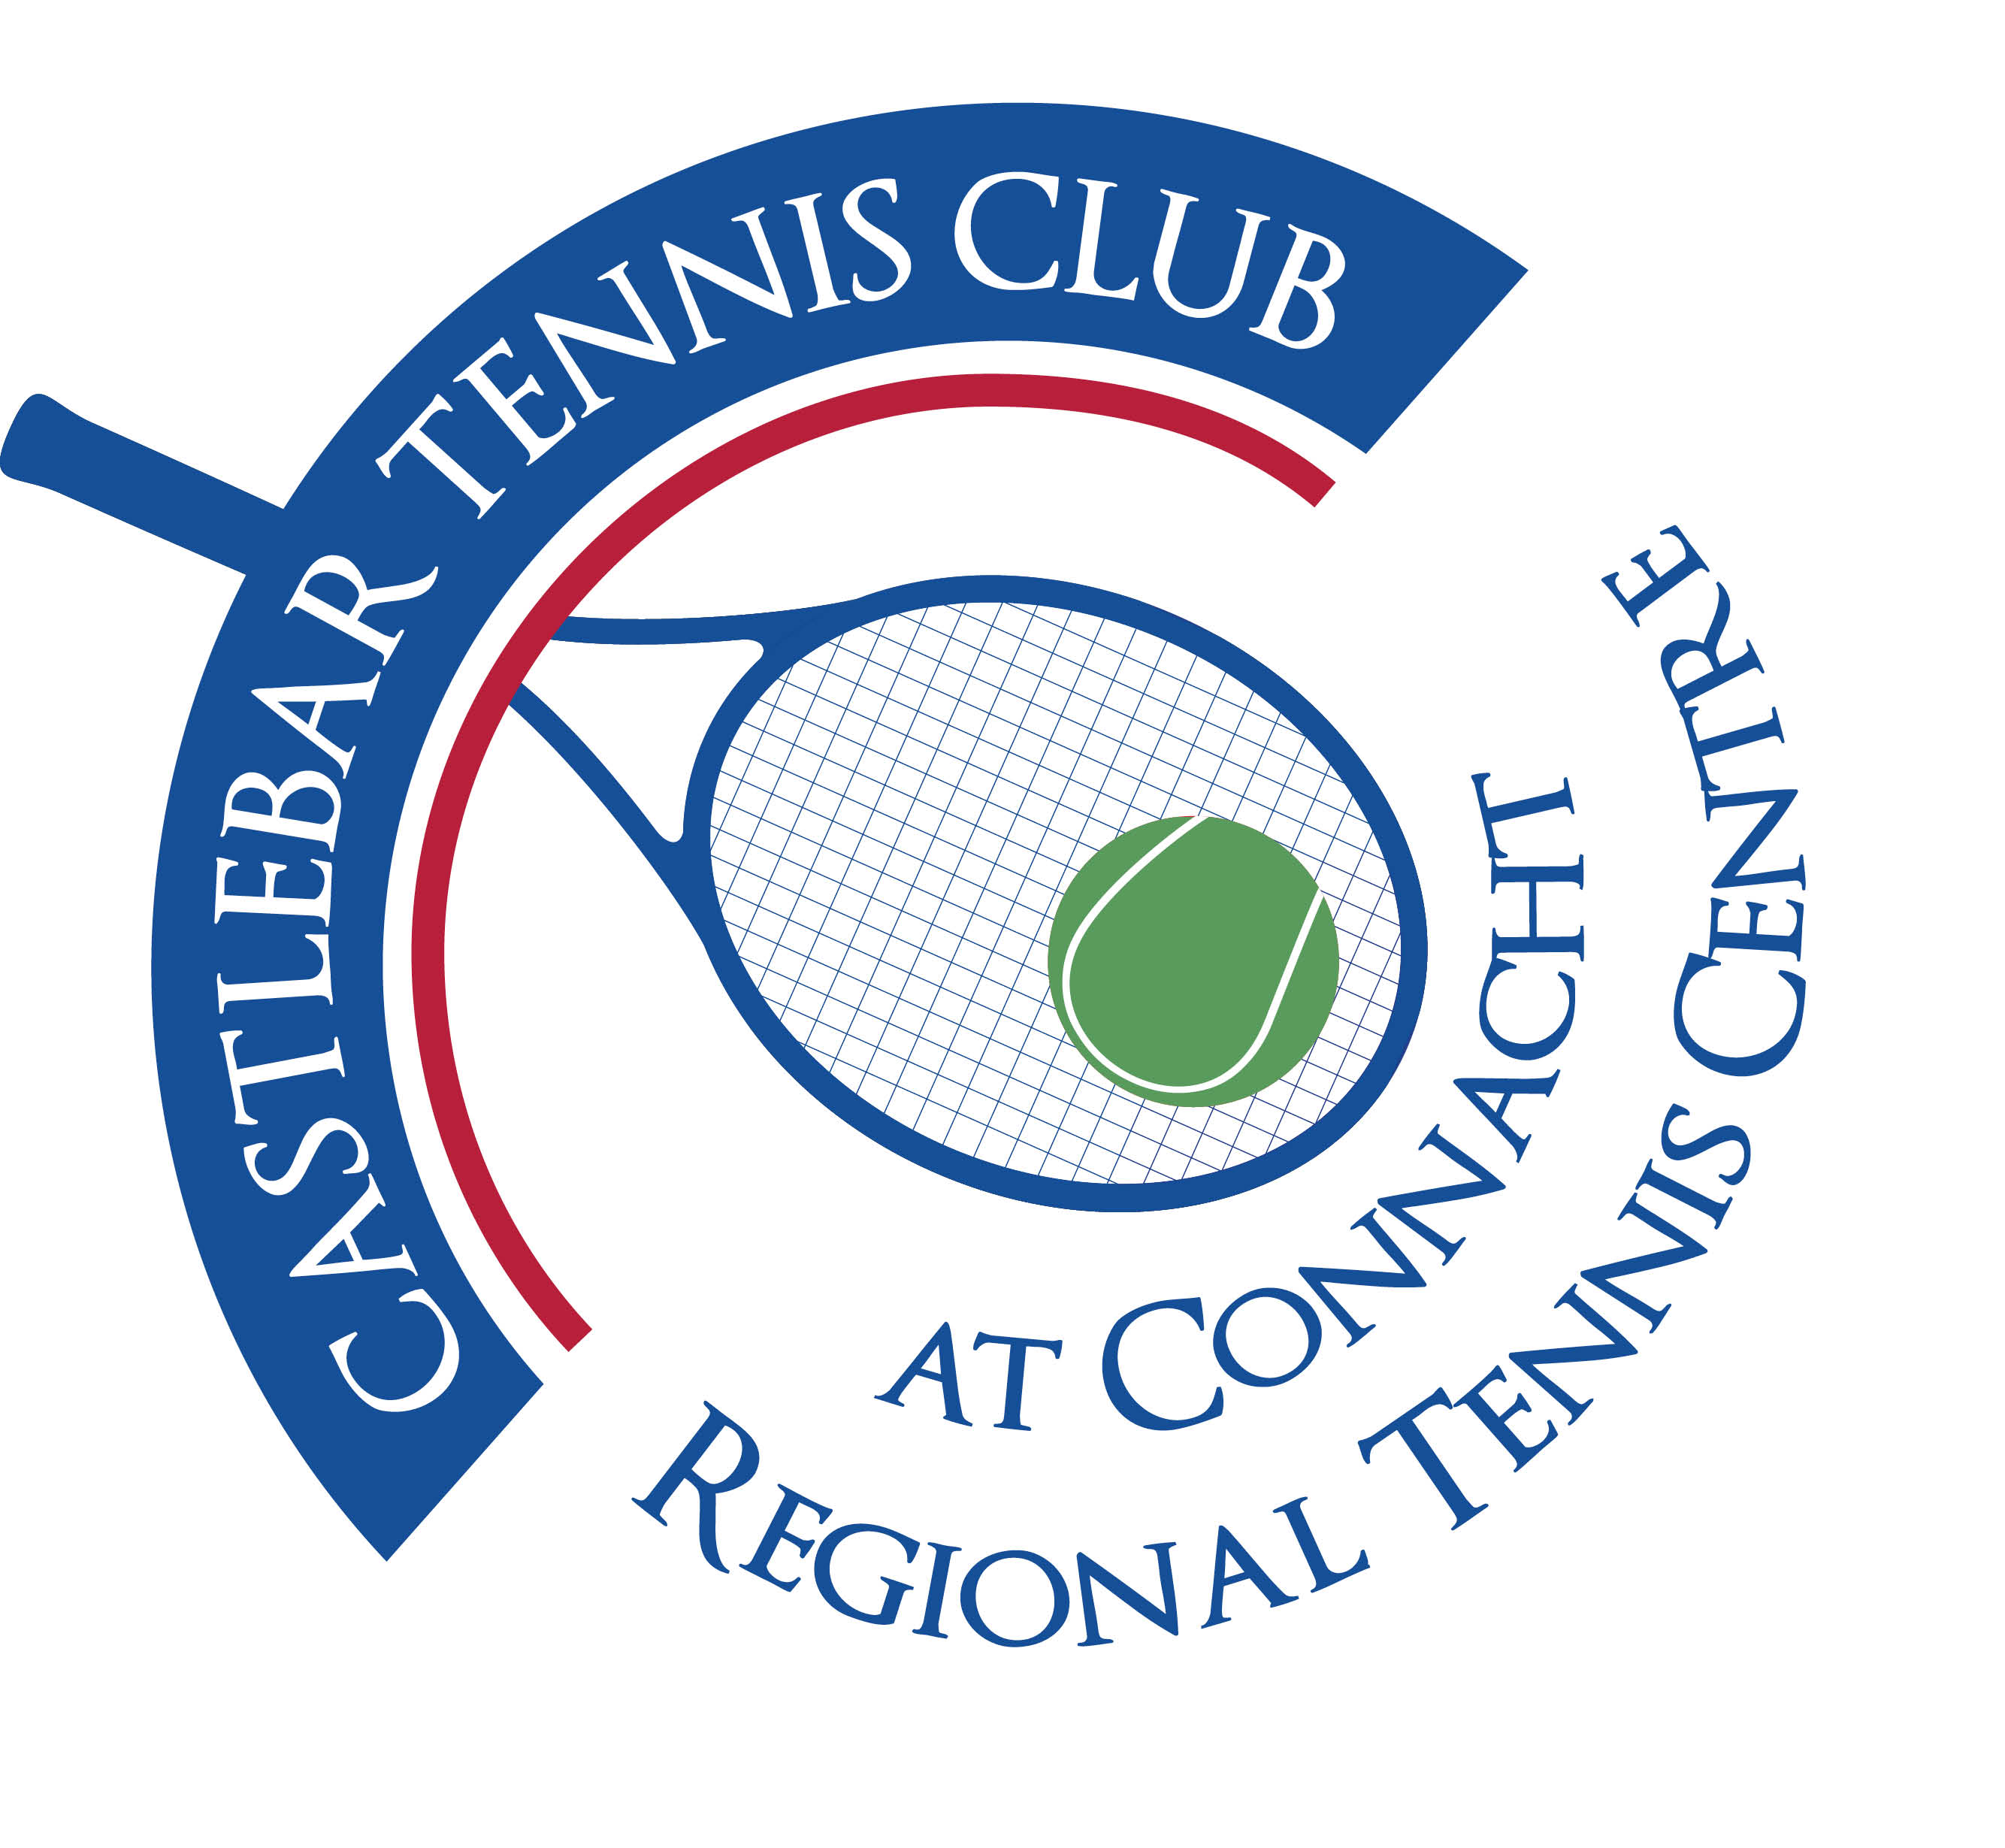

Castlebar Tennis Club

Committee Meeting

MINUTES – 21.08.23

**--------------------------------------------------------------------------------------------------------------------------**

* **Review & adoption of previous minutes –** Proposed by

Seconded by

* **Chairperson’s Update – PQ**
* **August Weekend Recap** – Weekend was a great success!
  + Perhaps start matches earlier(8am)so they don’t run as late as they did on the Sat night.
  + Club made almost 8k.
  + Accommodation: Members may be interested in letting a room while the tournament is on next year – make it more affordable for those travelling. Something to consider for next year! Another alternative could be a campsite on the green area behind the dome.
* **Lights/Outdoor/ Focus -** The outside court lighting wasn’t great during Aug weekend according to feedback from some players. The lights were glaring. Maybe they need to be refocused? Better if they were changed to LED. John O’M to contact Electric Skyline again.
* **Wheelchair Access Timeline**
* **Car Draw** – Tickets being printed next week. It will be back online again as our licence was granted. Main push will be on social media. Date for draw is December 15th.
* **Signs** – Signs on outside of clubhouse being updated by Paul.(correct fees, contact numbers,etc)
* **Club Management and Removal of Cash** – Garrett presenting at the end of this week. He and Olwyn plan on working together at the role of Club Manager(basic retainer, incentivised for more payment). Patrick has stressed that all payments must be online for transparency. Green fees will be built-in for any non-members who receive coaching at the club. Also temporary membership should be built-into terms and conditions so non-members are covered under our insurance.
* **Connacht Representative on Board of Tennis Ireland –** Jim Rafferty is to be the new Connacht Rep. He is required to be a member of a tennis club in Connacht, ideally Castlebar as it is the regional centre for tennis. We will give him Honorary membership.
* **Padel -** EGM to be heldfor members next Tuesday evening 29th August at 7pm to inform members about the proposed padel venture and to take a vote before proceeding. We currently have 2 quotes in for 2 courts uncovered with groundworks both for approx 170k. We will apply for planning for 3 courts maybe covered and go for regional sports capital funding?
* **John Griffiths –** He may return to work at the club. The position however has been advertised for anyone who has been unemployed longterm.
* **Treasurer’s Report - NF**
* **Finances** – 45k in the bank. 3k coming in membership subscriptions every month.
* Electricity bills currently 11/12k, that will increase.
* We’re in arrears of 30k with our mortgage, bank not happy with that. Hopefully we can make a profit with the car draw to pay a lump sum off the mortgage.
* **Secretary’s Report - ED**
* Membership – YTD
* Other
* **Coaching Report – GB/O’OT**
* **Captains Report – NK/TM**
  + **Tennis Update –** Doubles Ladder to start in September
* Club Championships in October to run for a week/fortnight
* Vets Tournament 17th – 19th November
* **PRO Report - GC**
* **Child Protection**
* **AOB**

**Next Committee Meeting to be held on Thursday 21st September, time TBC**