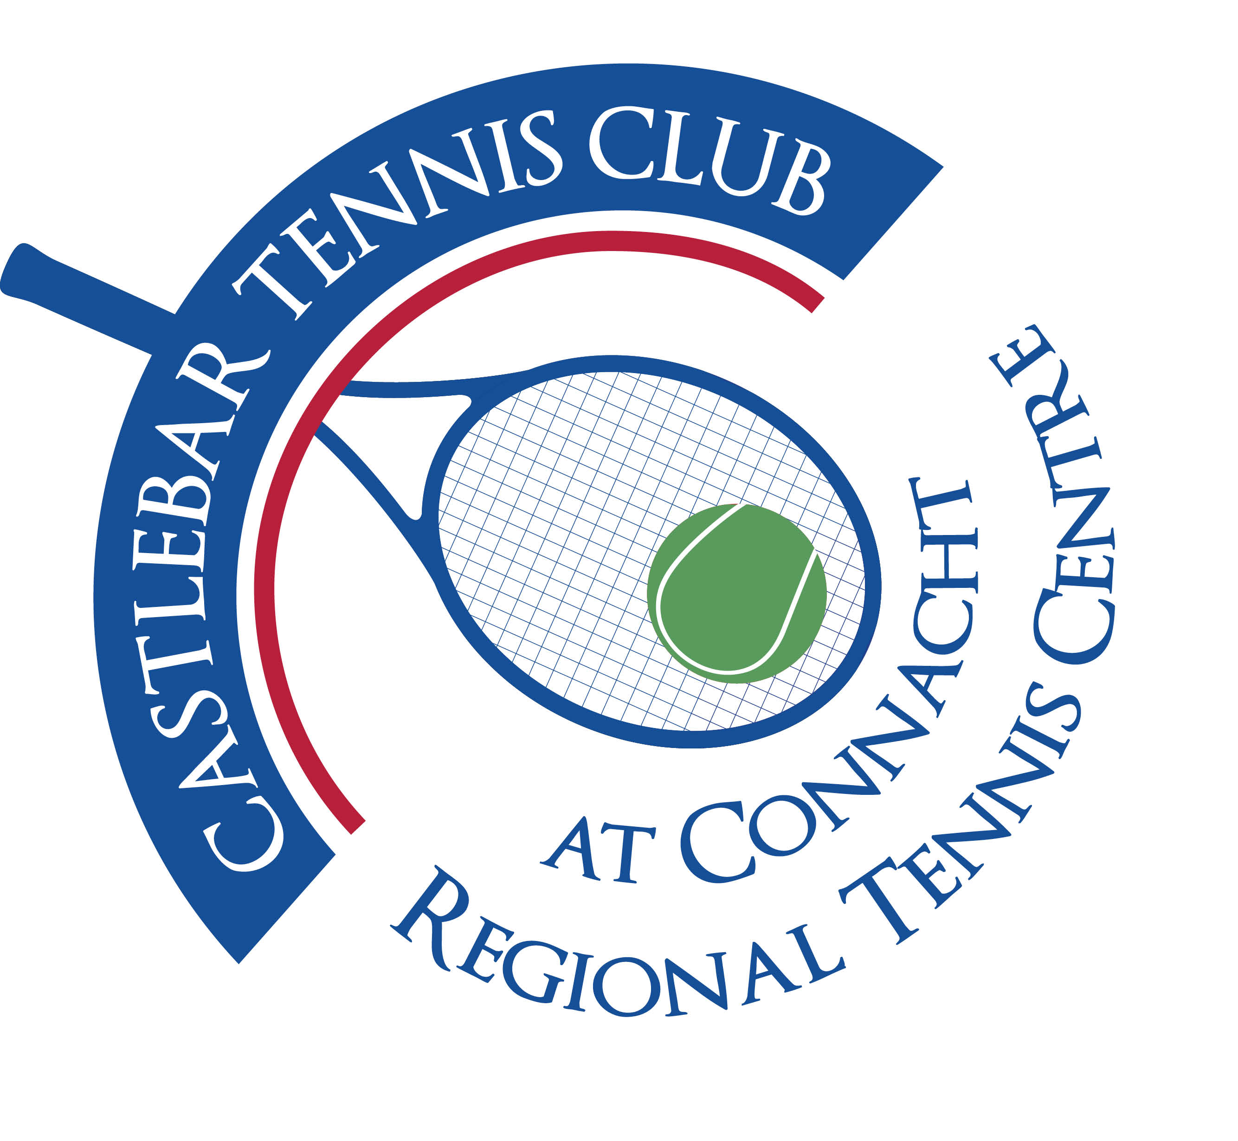

Castlebar Tennis Club

Committee Meeting

MINUTES – 21st March 2024

**--------------------------------------------------------------------------------------------------------------------------**

**Present:** Patrick Quinn, John O’Malley, James Durkan, John Feerick, Alma Egan, Niamh Kilroy, Kevin Durcan, Grainne Cashin, Fiona O’Malley, Noreen McNamee, Emer Dunne

**Apologies:**

1. **Chairperson’s Update – PQ**

* **Dome Update: (James Durkan)**The committee discussed the progress of the dome project, including the update on companies contacted for quotes.
* Bridome, Duol, Rocklyn and Polyslovakia (among others)have been contacted. In total seven quotes have been given for the project(large range of prices).
* Rocklyn has quoted €275,000 ex VAT to cover four courts with a 3rd Generation dome.
* Polyslovakia Ltd also provided a quote, which is cheaper but there are parts of the job which they haven’t included. Also they are reluctant to travel unless they have a good chance of securing the work.
* Bridome can install a mini dome for spectators and access to the courts.
* The cost is estimated to come in around €300,000 plus whichever company we go with.
* If we go for a similar size dome to our previous one we shouldn’t need to look for planning.
* Galway TC sent email to all members with 4 options:

1. Replace with like for like dome
2. Install 3rd Gen dome(they are only €50k short)
3. Cover 4 courts with a modular structure now, cover 2 more at a later date
4. Go for a permanent structure over 6 courts at a cost of €1.5 million.

It looks like they will go for covering 4 courts now(in the short-term) with a 10 year plan of covering 6 courts permanently.

* **Funding Update: (John Feerick)** Our target is €320,000.

1. SCG – Hopefully get €200,000(but not guaranteed). Will be announced in April
2. TF – Need to think of a fundraiser to run in the theatre(we have it free of charge). John in contact with Mandy Maher(influencer). Could organise afternoon tea, Grainne Seoighe to MC, models showing outfits from local stores,etc. Costs would be high though. Any other ideas??
3. Community Recognition Fund-for communities that have integrated members from elsewhere(Ukranians, etc). John spoke to Pat McHale who said to send expression of interest. Last year this grant ranged from €20-€50k.

* **Other possible sources of funding:** GMA allocations from local Councillors(they have each received an email from the club asking for funding).
* Naming rights for each court - €5000 per court for 3 years. John has already secured someone for one of the courts. Need to target big businesses for the other 5 courts.
* Carpark agreement – this will be up at the end of the year.
* Social night here at the club to watch the Oskars movies from 2020. Invite Castlebar Celtic and Castlebar Mitchels to come. Should be a good night for the bar!
* **GoFundMe Update:** (**Noreen McNamee)**€36,721 in GFM account as of 21.03.24. We have savings of €26,000. This means approx. €60,000 available for the dome project.
* **Membership renewal(James Durkan)**

422 members currently, 195 adults and 52 juniors have renewed. This means 132 memberships have expired(90 expired more than 2 weeks ago). No email reminder went out to members about renewing. We need to email members, this may be the reason that some have not yet renewed.

* **\*Rota to cover Paul’s absence* N.B.** (See AOB)
* **Decision on New Coaching Plan**
* Garrett and Olwyn will finish up at the end of June. We need to draw up a document outlining the role of head coach/admin to take over. Would Daniel Glancy take over? Or do we need to hire a Club Admin and if so do we have the budget for it? What about Jan who currently does most of his coaching in Westport, we can’t assume he will come back to Castlebar. Ideally we probably would need 3 coaches- e.g.Daniel, Jan and 1 other for recreational groups.
* Committee needs to get notice if courts are to be block booked at weekends for competitions. Coaches can provisionally book them but committee will have final say.
* We need to put together a template of what we want the coaching structure to look like after June. Sub-group get together to discuss what we want/decide the role description,etc.
* **Integration of New Booking Time/Integration of New Multiple Slot Booking**
* **New Booking Time –** Will be now from 10pm (this needs to be changed on the system and message sent to members to inform them of same)
* **Multiple bookings -** Before 3pm and after 8.30pm, minimum of 8 people, submission to be made to the committee

1. **Treasurer’s Report - NMcN**

* Finances – State of play

**Bank figures:** Main a/c €24,283

Bar a/c € 1,783

Membership a/c € 9,082

Savings a/c €26,000

* Other
* Noreen has updated mandate in Bank.
* 2nd Key to drop-safe is missing(Noreen has 1). Maybe John Greenan has the missing key?
* Vending machine – not taking cash, needs to be looked at/repaired.

1. **Secretary’s Report - ED**

* Membership – See ‘Membership renewal’ above. Update: Emer will locate membership renewal letter template on AceBook and send to members that have yet to renew.
* Other

1. **Coaching Report – GB/O’OT**
2. **Captains Report – GC/JD**

* **Tennis Update**
* Coaching – ‘Couch to Court’ started last Monday.
* Easter Fun Friday planned for Friday 29th April (no charge for Fun Fridays)
* Captains plan to run a Spring League, Ladder and more clinics (doubles tactics/ backhand,etc)

1. **PRO Report - GC**
2. **Child Protection – BC-**nothing to report
3. **AOB**

* **Access and lock-up(in preparation for Paul’s absence) –** Need a rota from Easter Weekend (Paul unavailable from Wed 3rd April). Emer to meet with Paul(check groups who use hall/courts, who can open/close without help from committee members,etc).
* **Need committee members to take on the following areas: Bar/vending machine**
* **Kitchen and catering/food for events during year**
* **Kid’s Disco – possible fundraiser? –** would have to contact the insurance company, trouble at recent kids disco in Celtic, would need a lot of supervision.
* **Conflict of Interest –** Alma’s brother works with Norwegian, they would be interested having a meeting with regard to the possibility of setting up EV charging points in club carpark. Cost to set up would be €20k-€40k(company covers this-no cost to the club). The club could make money from it. It would be a 10 year contract. John O’Malley to read the proposal/meet Alma’s brother to discuss.
* **Mailchimp-**Patrick to set up mailchimp with a view to monthly newsletters with club updates being emailed out to members(committee members to take turns to put newsletter together ready to send out).

**Next Committee meeting scheduled for Thusday 25th April at 7pm.**

**Hope to see you all there.**

**Kind regards,**

**Emer.**