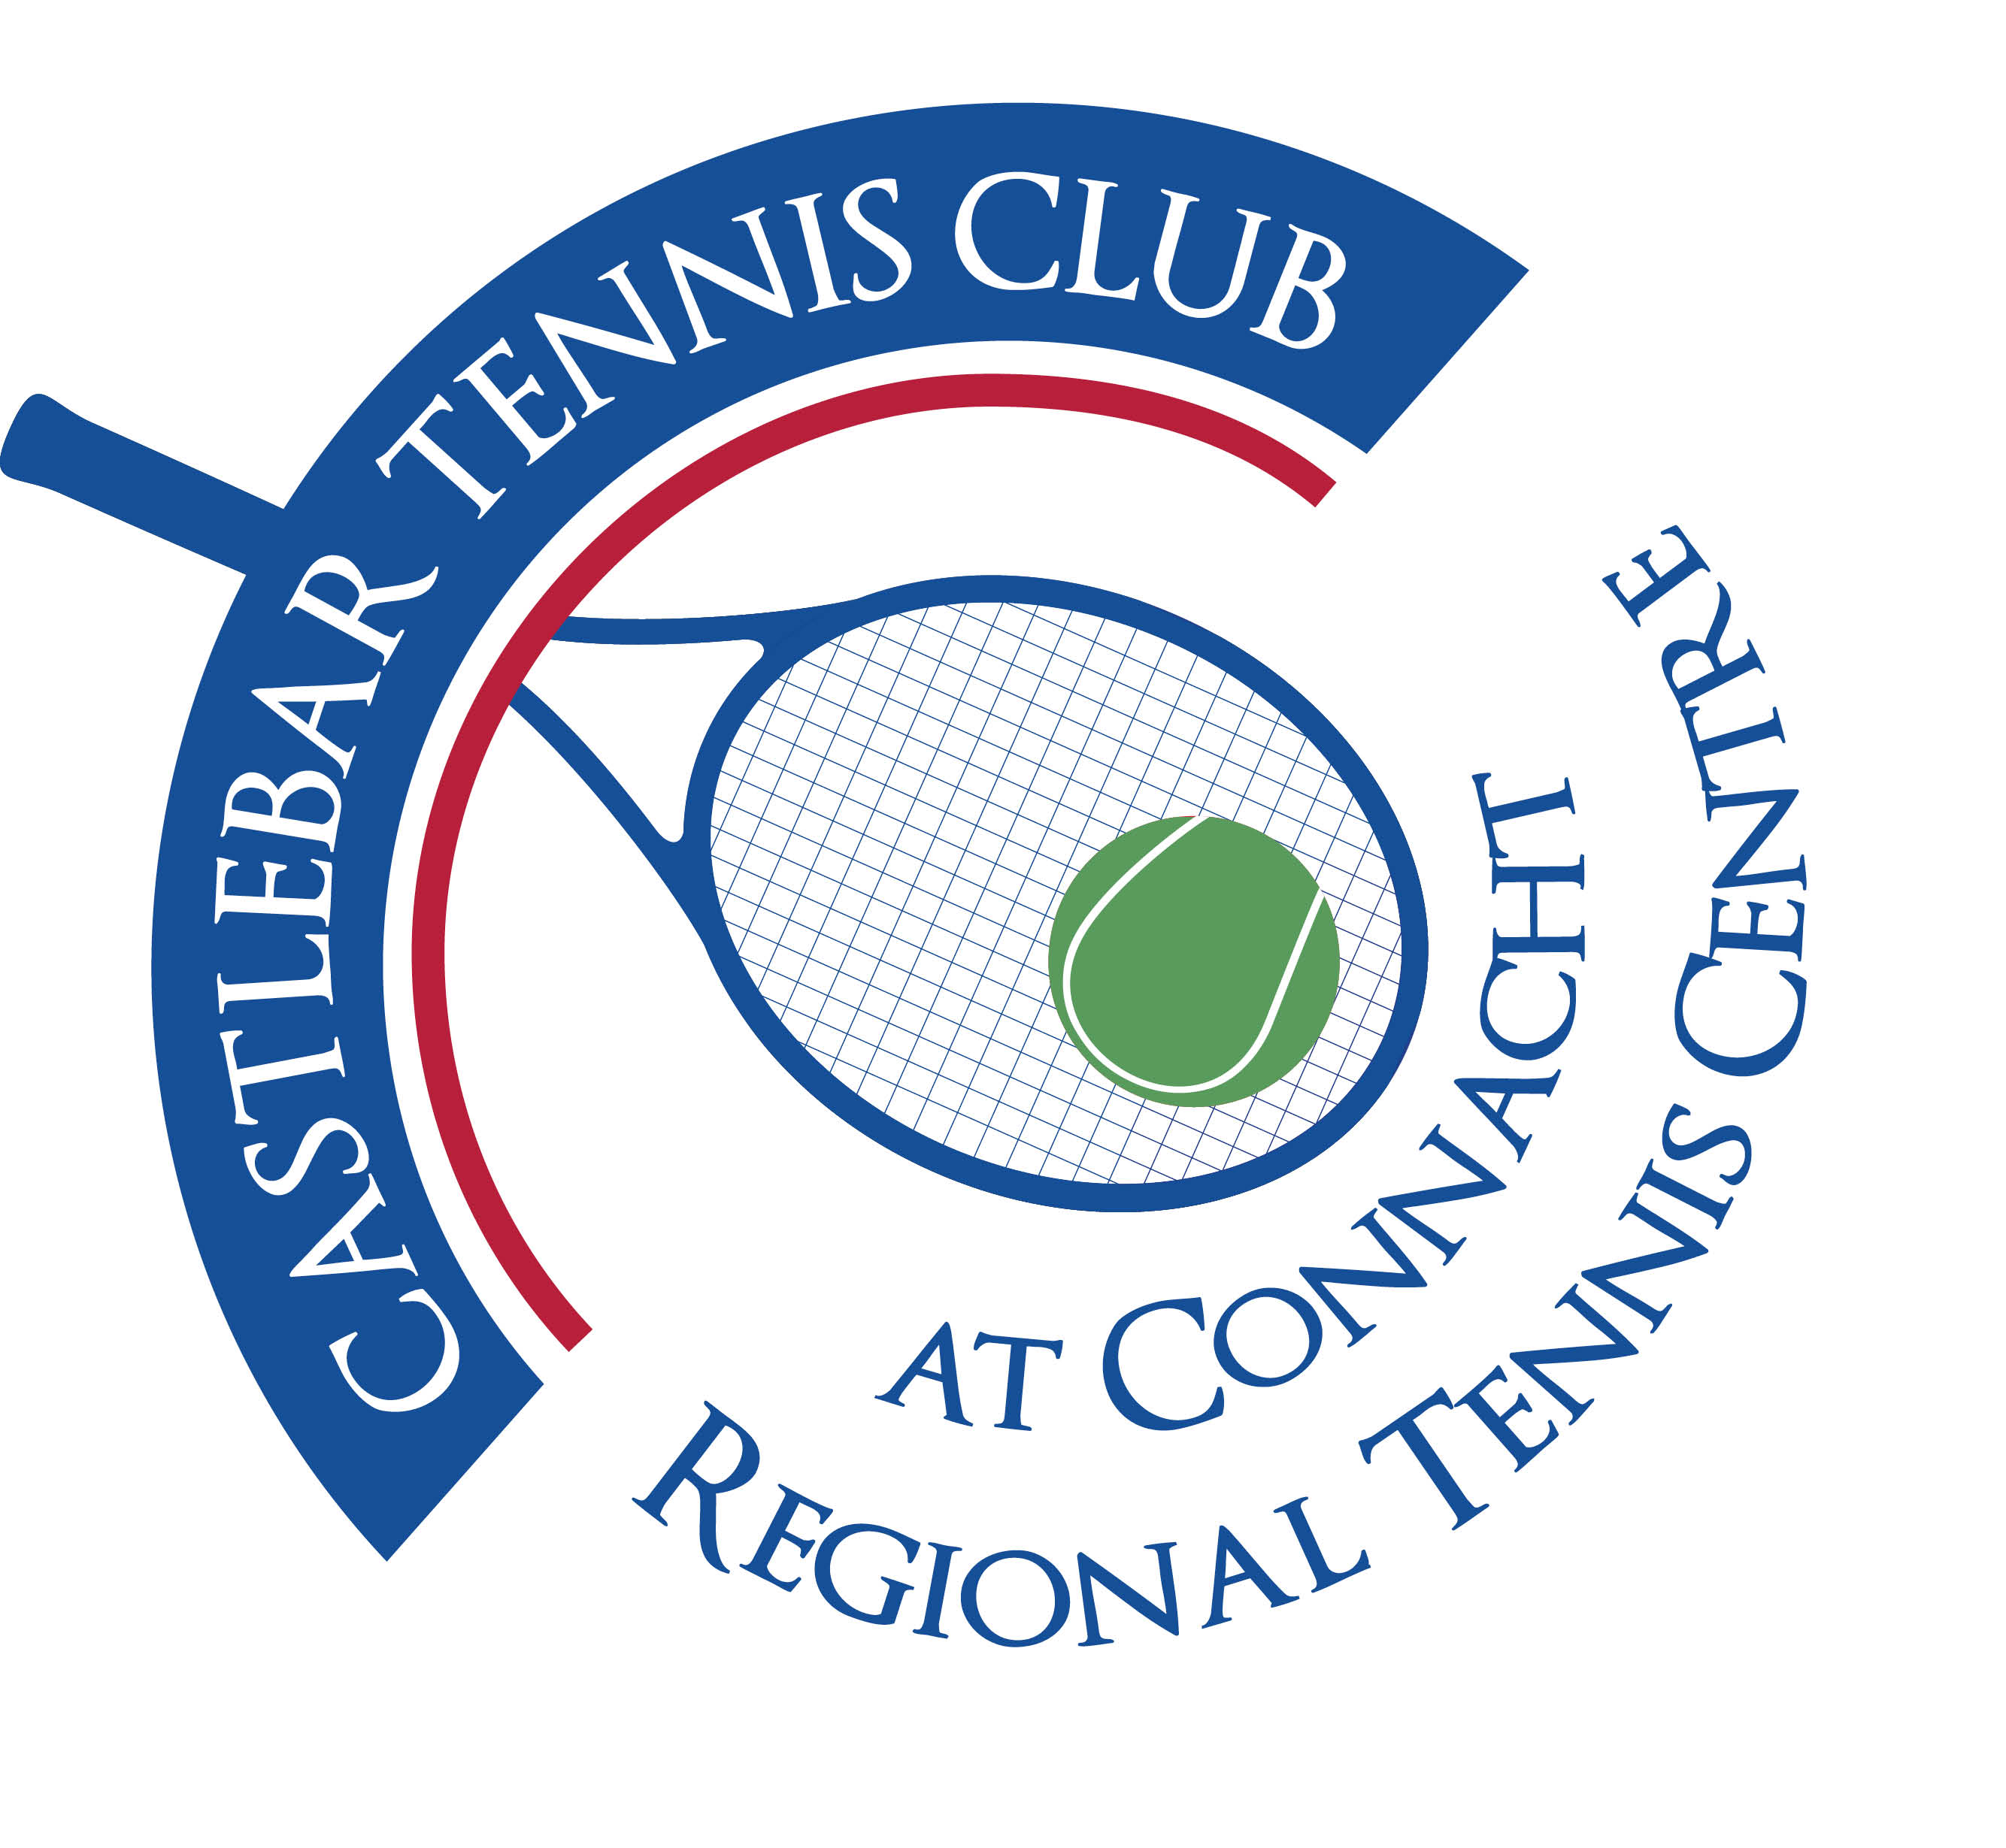

Castlebar Tennis Club

Committee Meeting

AGENDA – 11th July 2024

**Present:** Noreen McNamee, Finoa O’Malley, Grainne Cashin, Alma Egan, Tony Mannion, James Durkan, Emer Dunne, Niamh Kilroy, John O’Malley

**Apologies:** Patrick Quinn, John Feerick, Paul Meldrum

1. **Review & adoption of previous minutes –** Proposed by

Seconded by

1. **Chairperson’s Update – PQ(Noreen)**

* **Dome Financing Update** – Expression of interest submitted to Mayo CoCo for Community Recognition Fund. We applied for €270k. They would like more information on:

(a) public access – eg green fee/ honour box/ acebook green fee bookings, maybe courts 1 & 2 could be made available to the public for 2 hours on a Saturday morning at no charge?

(b) our own funding – match funding will be needed, possibly 10%,

(c) economic benefit the club brings to the town – eg tournaments bring revenue to the town.

If successful would probably be September before a letter of offer would be received.

* **Petanque** – contact with Graham in Mayo Sports Partnership. Looking to install a pitch(gravel base)in Castlebar. Could go to the right as you drive in through gates of club. There would still be room for Padel courts between it and courts 1 & 2. Could have Connacht Petanque based at Castlebar Tennis Club! Money available to install pitch. Membership – players pay to use the facility and so would be covered by club insurance.
* **Dome Quote Update** – Put our cap at €300k max. Dome sub-committee to meet next week. Need to get updated quotes, ascertain what exactly is included for the price and find out how much downpayment would be( we may be able to cover this with our own funds). Cut down to 3 main contenders. Prunty who installed dome at Bekan seem to be the forerunners at the moment!
* **Letters of complaint** – n/a
* **Donations –** Rotary Club raised €1700 through a raffle for dome fund and Dave O’Malley donated cheque for €500 for same. Both have been sent thank you letters.

1. **Treasurer’s Report - NMcN**

* **Finances** – State of play

Currently: Main a/c - €20,659

Bar a/c - € 5,097

Membership a/c - € 3,865

Savings a/c - €63,475

* **Other** – Club insurance, electricity, Imro all paid and these figures reflect the payments

1. **Secretary’s Report - ED**

* **Membership**
* **Other** – notice of bar licence renewal has come in

1. **Captains Report – GC/JD**
2. **Tennis Update** – a. Couch to court with Jan
3. Parks tennis(kids summer camps)
4. Improvers/advanced/intermediate lessons with Daniel
5. Ladder just set up
6. **PRO Report – GC**

Plenty of activity on Facebook, etc.

Keep sending relevant photos/info to Grainne to post!

1. **Child Protection – BC**

Letter for Patrick to sign

Nothing further to report

1. **AOB**

* **August Weekend Tournament 2nd – 5th :** Will need a separate meeting to discuss this. Plenty of jobs to be sorted (eg Donie to check bar stock, Sunday night BBQ tickets, raffle on the Sunday night? Music, etc)

**NB** Court lights need to be checked before the tournament as matches can go on late at night. Maybe override the hour buttons so lights won’t go off during matches.

* **EV Charger Point –** we need to move with this or we’ll lose out on the opportunity for this year. Civil works will need to be carried out. It will use metered power (so can be seen separately on electricity bill). Noreen to check with Patrick about signing off on it(maybe get solicitors to check it out).

**Next meeting TBC.**