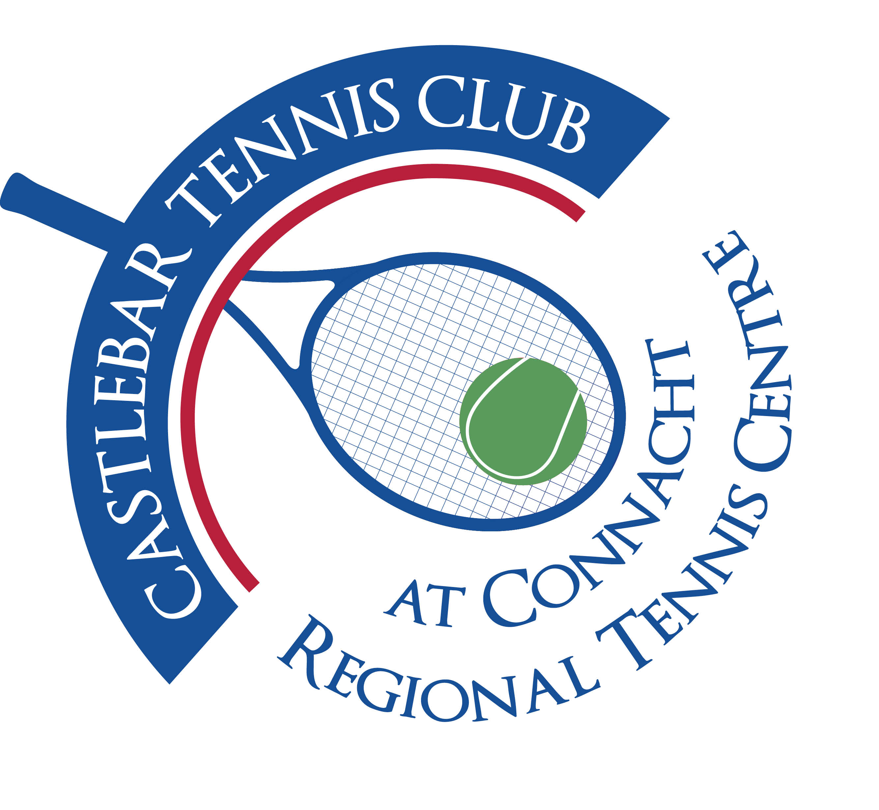

Castlebar Tennis Club

EGM MINUTES-

Tuesday 29th August 2023

**Present:** Patrick Quinn, Emer Dunne, Paul Gavin, Salim Khan, Diane Kellett, Fiona Rowland, James Durkan, Pat Conlon, Niamh Kilroy, Alma Egan, Grainne Cashin, John O’Malley, Bernie Burke, Katrina Conlon, Jeananne Garavan, Bernie Caulfield, Paul Heverin, Adrian Gavin, John Feerick, Sue Baird, Ard Van Balkom, Garrett Barry.

**Apologies:** Anne Tobin, John Kilkenny

* The purpose for calling this EGM was to inform members that there we have identified potential funding to install padel courts at Castlebar Tennis Club and to discuss the location of these on the club site. Then to have a vote on this proposition.
* Patrick Quinn started proceedings by telling members that no application has been made formally yet. We had to have had a pre-planning meeting due to the closing date coming up. Having a planning number will give us more points on our application. The notice is in the newspaper today.

**Q. What will the courts be like/look like,etc? Will they be on an existing court? (Diane)**

**A.** No, the courts will not be on an existing court. They will be on the green area to the right of the gate as you drive in to the club.

The application is for 3 courts, 2 will be built first, with groundworks in place for a possible 3rd court. Each court measures 10m x 20m, it’s a doubles game mostly.

Cost: 180/190k without covers(double that with covers). Applying for the amount to include covers may be prohibitive to our application. They can always be added at a later stage.

We would hope to get up to 75/80% of the funding needed.

The courts are surrounded by glass and mesh 3m high.

The official padel ball is slightly larger than a tennis ball, but most people use tennis balls when playing. You use a bat with holes in it to strike the ball. The back wall is used for the ball to rebound off(not unlike squash).

There is a choice of 3 court surfaces, the most common for outdoor being astro.

Lighting is integral.

Padel is very popular in the East of Ireland, in the UK and Europe, especially young adults. It will be made available to Castlebar Tennis Club members without any extra fee (hefty green fee for non-members). It would have to be gated for security.

**Q. Will the padel courts be on the same booking system? (Pat)**

**A.** Yes that should be the case.

**Q. Will there be a viewing area for the padel courts?(Pat)**

**A.** Yes that will be in the plans.

**Q. Would these be the first padel courts in Connacht? (Paul H)**

**A.** Yes and the first along the west coast.

Adrian has seen lots of padel courts in small towns in Spain. It appears to be a very sociable sport. Very varied ages in people playing. You have less ground to cover!

**Q. How long will the project take?(Katrina)**

**A.** This would depend on when the funding would come through, approx 3 months after that.

**Q. Will we need to fundraise?(Katrina/Sue)**

**A.** We would need to cover the remaining approx 25% of funding needed. We don’t envisage that this would be through borrowing.

**Q. Do we require planning?(Bernie C)**

**A.** Yes planning permission is needed. It will be submitted by the end of this week.

**Q. What if it doesn’t work out(ie padel doesn’t take off like we hope)?(Diane)**

**A.** We could easily convert the padel to tennis courts. The groundworks would already be in place. It would only really be resurfacing needed. It’s good to have a contingency plan in place in case it all doesn’t go according to plan.

**Q. What kind of prep work is needed on the site & cost? Will there be drainage issues?(Fiona)**

**A**. To the tune of 70k. The ground will be at the same level as the existing outdoor tennis courts. There will be sub-surface drainage under the courts.

**Q. Do we envisage having a separate club for padel?(separate membership,etc)(Bernie C)**

**A.** Ideally it should be more beneficial for people to be members of the tennis club.

**Q. Are all padel courts affiliated with tennis clubs in Ireland? Hotels abroad have their own padel courts.** (Paul H)

**A.** Currently we think all padel courts in Ireland are located in tennis clubs, however Ashford Castle are looking at putting a padel court in!

Padel will attract sports people and clubs. We will ensure it is inclusive in all aspects(wheelchair accessible, etc). We will also include a ramp down to the dome in our application.

**Voting result:** The outcome of the voting was a **unanimous vote of confidence** in favour of moving forward with the implementation of the proposed padel courts at Castlebar Tennis Club.

**____________________________**

**Emer Dunne**

**Hon. Secretary**