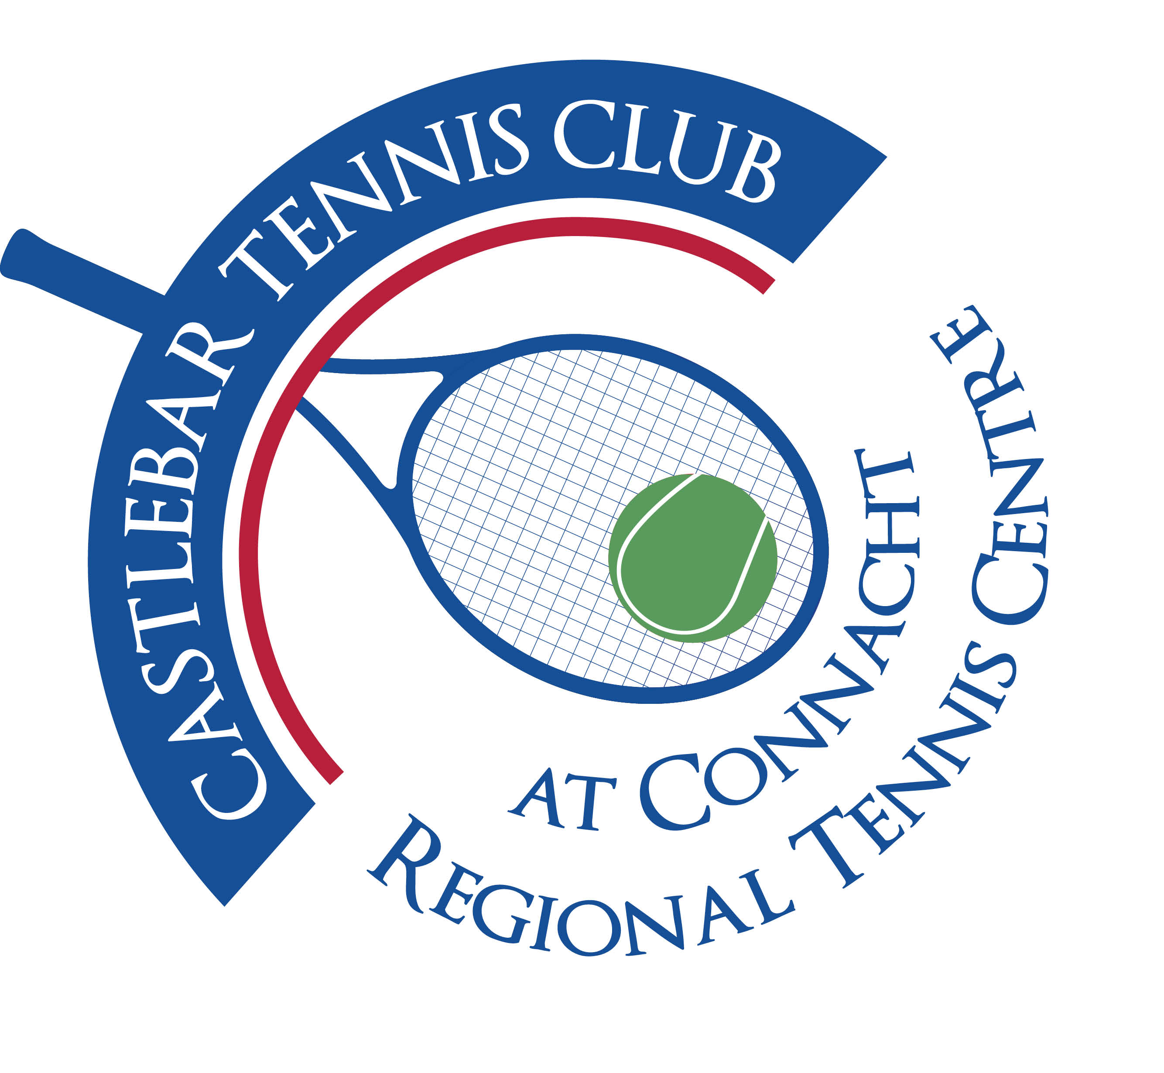

Castlebar Tennis Club

Committee Meeting

AGENDA – 30th January 2024

**--------------------------------------------------------------------------------------------------------------------------**

* **Review & adoption of previous minutes –** Proposed by

Seconded by

**Agenda items for discussion:**

1. **Dome update, to date**
2. **Dome quotes and Suppliers**
3. **Covering possibilities (discuss)**
4. **Funding Strategy, including GoFundMe, government funding, etc and others (discuss)**
5. **Current enhancements (discuss)**
6. **AGM Plan**
7. **AOB**

**Looking forward to seeing you at the meeting – should you be unable to attend, please let me know in advance.**

**Many thanks**

**Patrick Quinn**

**Chairperson**