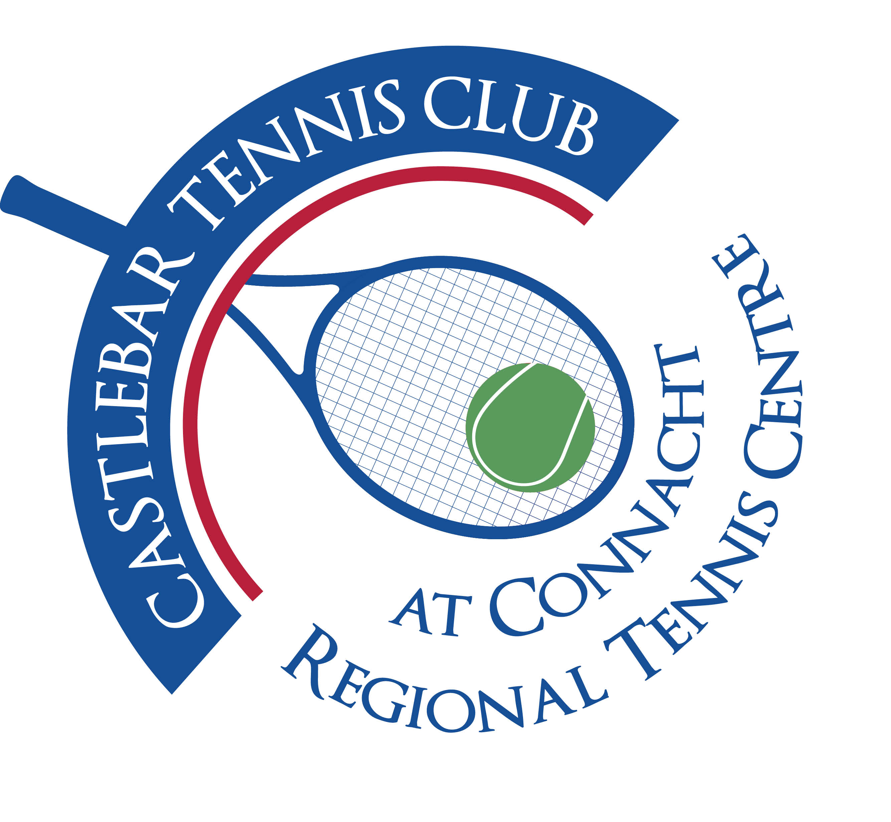

Castlebar Tennis Club

Committee Meeting

AGENDA – 29th May 2024

**--------------------------------------------------------------------------------------------------------------------------**

1. **Review & adoption of previous minutes –** Proposed by

Seconded by

1. **Chairperson’s Update – PQ**

* **Coaching agreement update(After meeting with coaches earlier in the day)**
* **Dome Financing Update**
* **Junior Tournament 21st-23rd June**
* **Dome Quote Update(Time to Make Decision?)**

1. **Treasurer’s Report - NMcN**

* Finances – State of play
* Other

1. **Secretary’s Report - ED**

* Membership
* Other

1. **Captains Report – GC/JD**

* Tennis Update

1. **PRO Report - GC**
2. **Child Protection - BC**
3. **AOB**

* **Bar Training**
* **Kitchen and catering/food for events during year**

**Looking forward to seeing you at the meeting – should you be unable to attend, please let me know in advance.**

**Many thanks**

**Patrick Quinn**

**Chairperson**