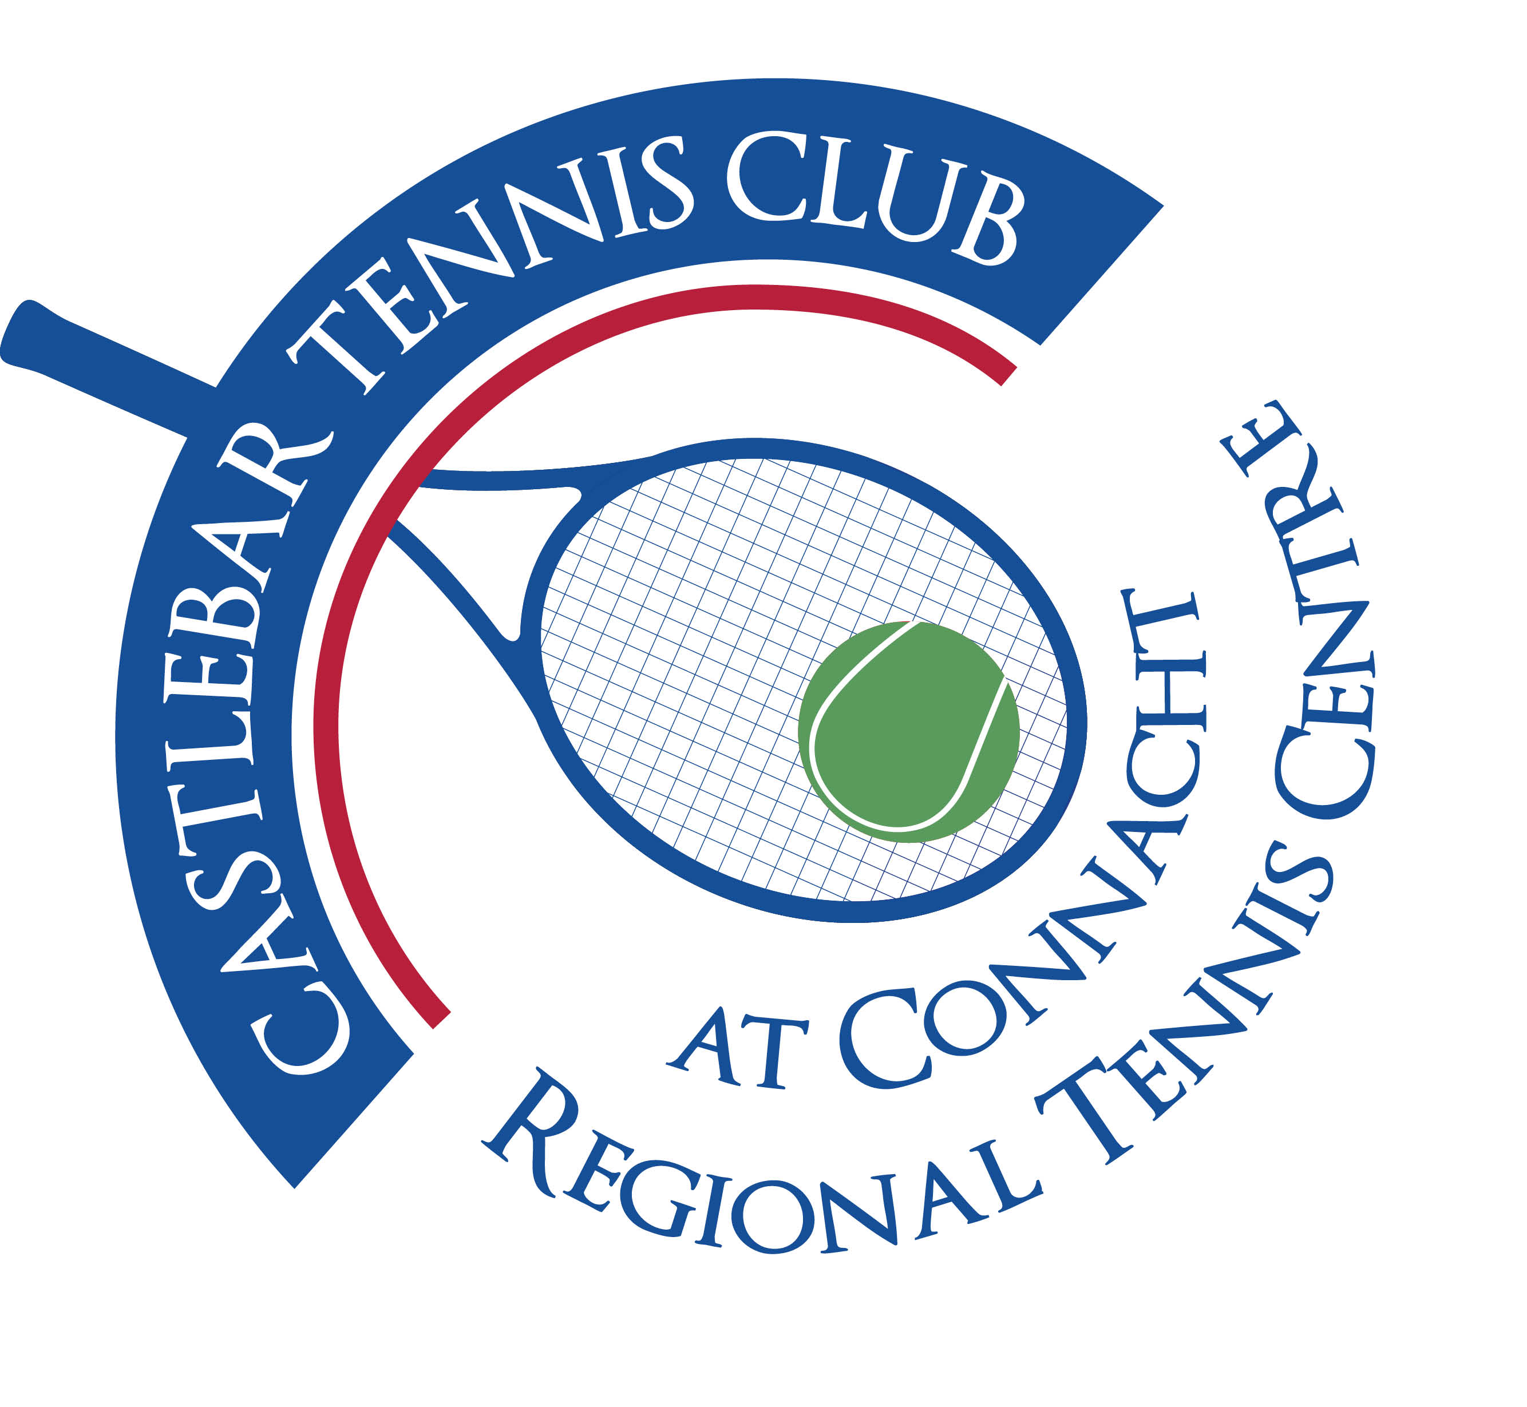

Castlebar Tennis Club

Committee Meeting

AGENDA – 18th January 2024

**--------------------------------------------------------------------------------------------------------------------------**

* **Review & adoption of previous minutes –** Proposed by

Seconded by

* **Chairperson’s Update – PQ**

**Pedestrian Access**

**Wheelchair Ramp**

**Agreement on TOU**

**AGM Prep**

* **Treasurer’s Report - NF**
* Finances – State of play
* Other
* **Secretary’s Report - ED**
* Membership – YTD
* Other
* **Coaching Report – GB/O’OT**
* **Captains Report – NK/TM**
* Tennis Update
* **PRO Report - GC**
* **Child Protection - BC**
* **AOB**

**Looking forward to seeing you at the meeting – should you be unable to attend, please let me know in advance.**

**Many thanks**

**Patrick Quinn**

**Chairperson**