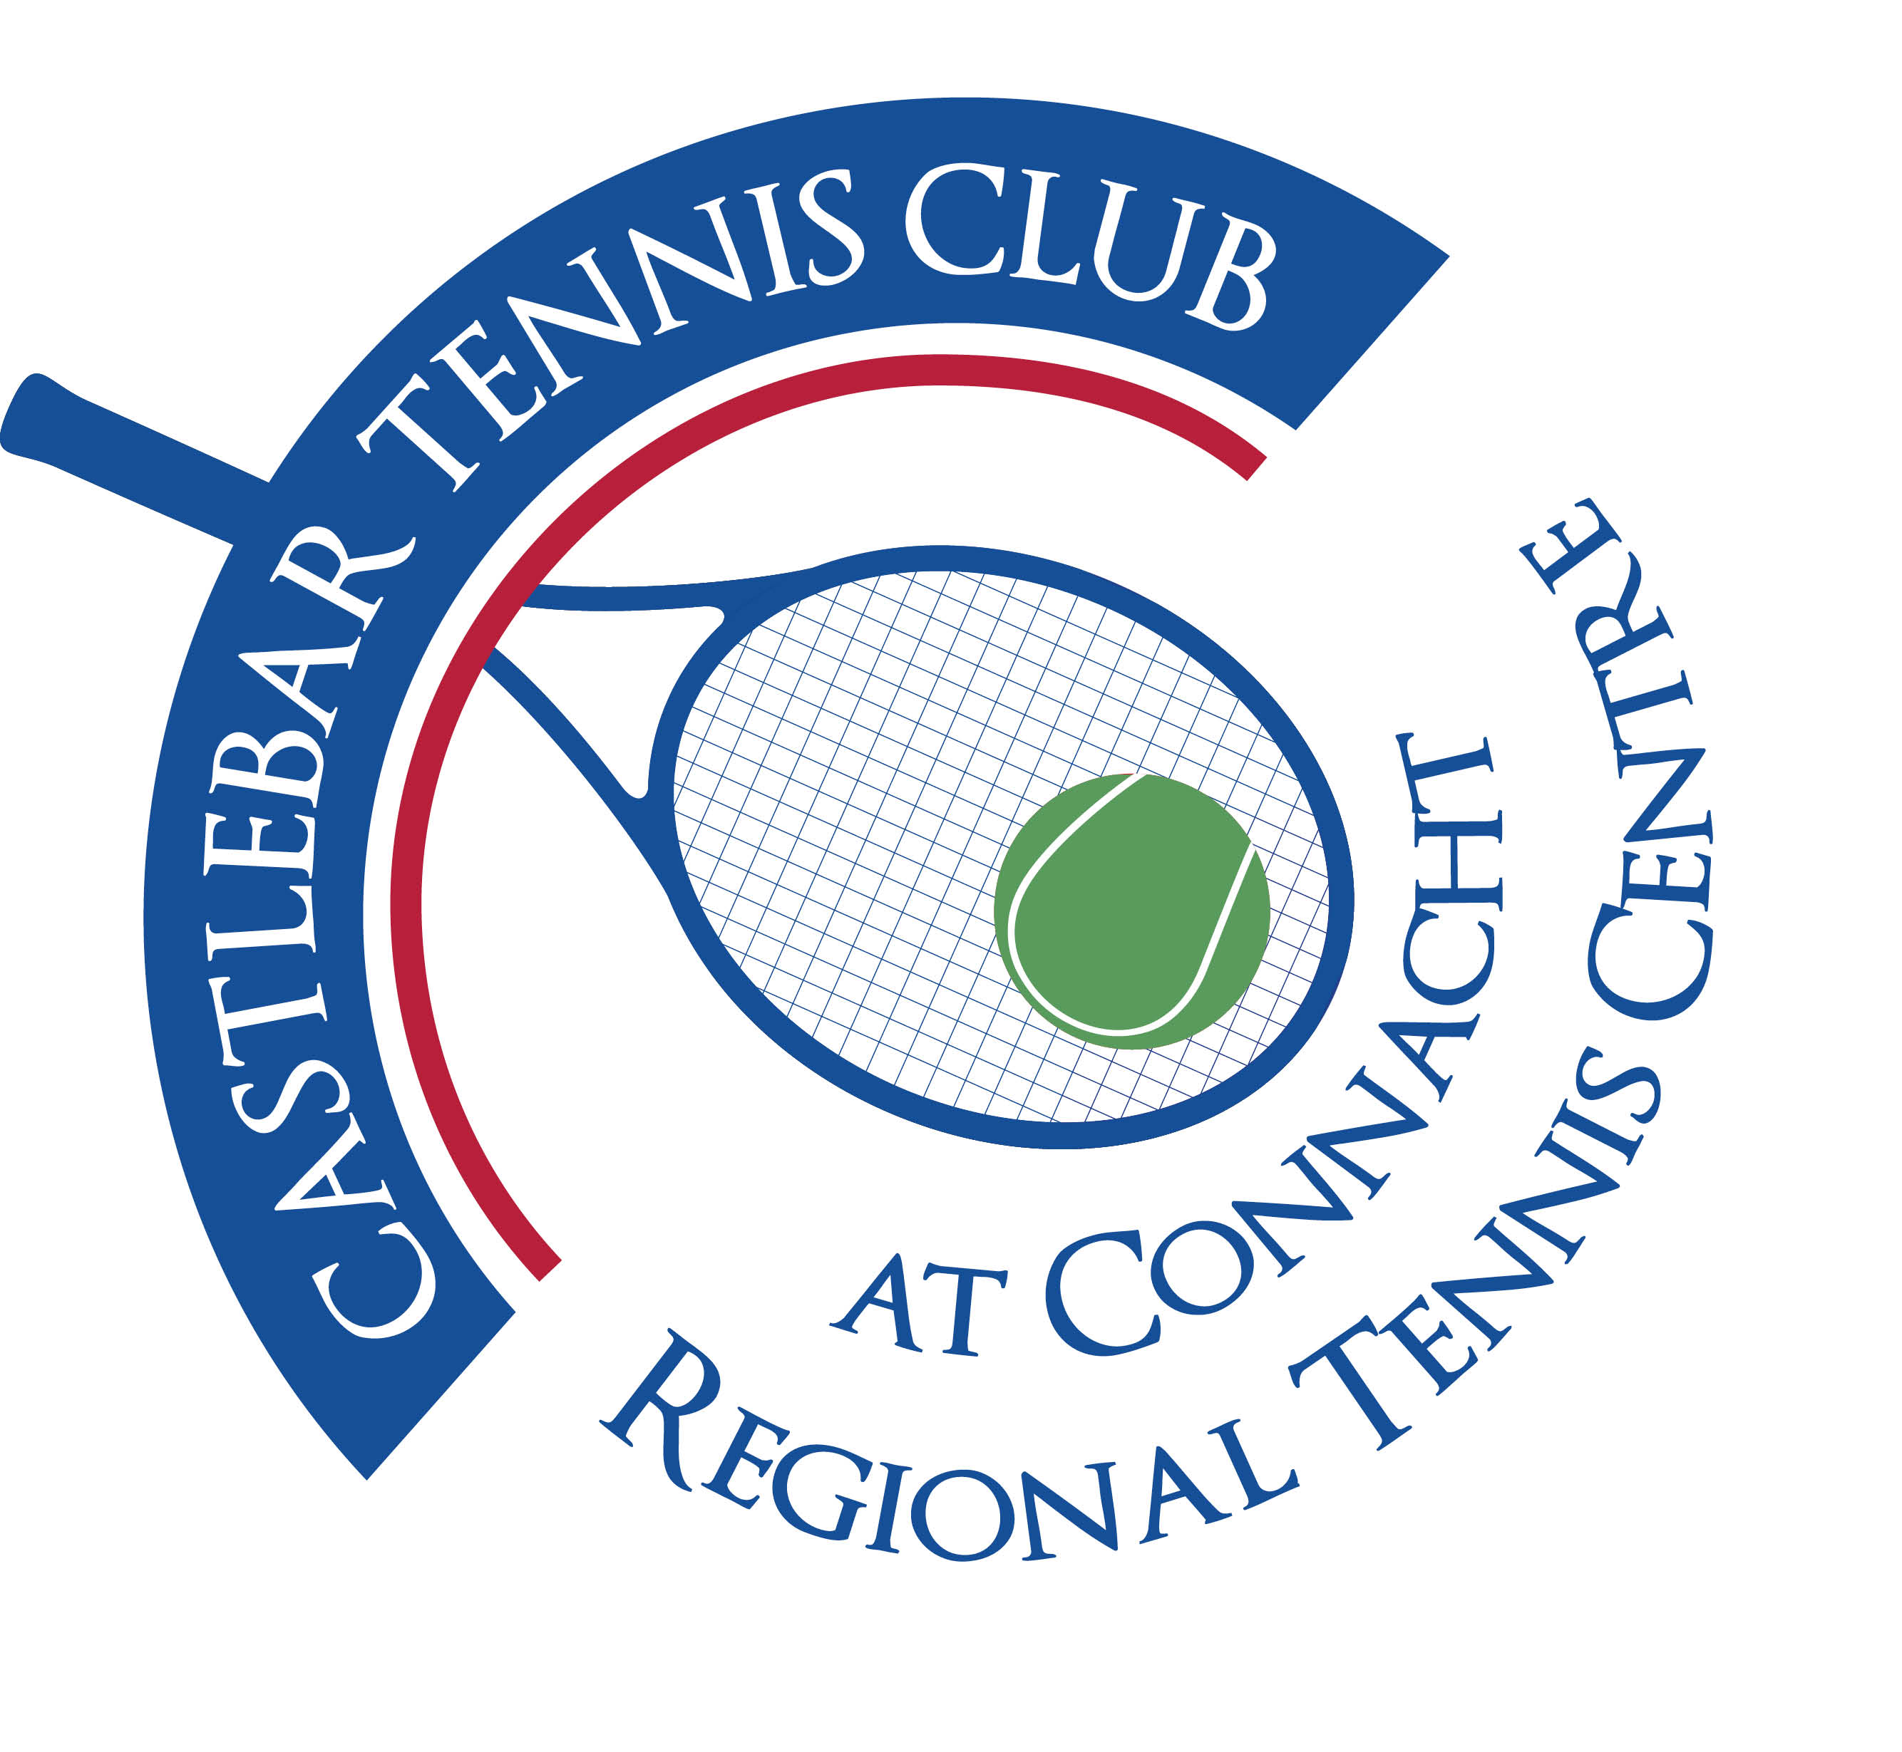

**Castlebar Tennis Club**

**AGM MINUTES**

**Tuesday 6th of February 2024**

**Present:** Gráinne Cashin, Noreen McNamee, Pat Conlon, Dara Dunne, Paul Gavin, Donal Coleman, Monica Doyle, Alma Egan, James Durkan, Siobhan Sheil, Katrina Conlon, Fiona O’Malley, Paul Meldrum, John Feerick, John O’Malley, Neil Ferriter, Margaret Glancy, Diane Kellett, Fiona Rowland, Salim Kahn, Emer Dunne, Patrick Quinn, Tony Mannion

**Apologies:** Bertha Munnelly, Brian Healy, AnnMarie Reilly, Sue Baird, Mary Ward, Patricia Armstrong, Bernie Caulfield, Niamh Kilroy

1. **Review & adoption of AGM minutes 2023 –** Proposed by Tony Mannion

Seconded by James Durcan

1. **Chairperson’s Report – Patrick Quinn**

* Patrick started out by outlining some achievements that we have made and challenges that we have faced over the past year.
* **Achievements:** New booking system – improved efficiency and accessibility of booking courts
* Automated lighting – took a while to kick in so not certain of savings made yet but is fully operational now
* Membership – this has seen remarkable growth, now stands at 408 members
* Finances – revision of fee structure has enabled us to manage operational costs
* Fundraising – mainly from our car draw which has made the club in excess of €20k(funds needed to pay off court resurfacing work)
* Competitions – feedback from visitors/competitors very complimentary, they were given a great welcome, lovely show of hospitality from our club. This should be lauded, put out there.
* **Challenges:** Tennis club getting busier – this has put pressure on courts. We had been about to implement some changes to help alleviate this, these have stalled due to the unforeseen circumstances regarding the dome, but they will be put into place and we can all play well together!
* Storm recovery – Storm Isha led to the loss of our dome and this poses a significant challenge for us. However we are on course to receive substantial funds through payouts, grants and fundraising, which currently exceeds €30k on our GoFundMe page. We are also being looked upon favourably as we have been proactive in raising funds towards a dome replacement, we haven’t just sat back waiting for handouts.
* The future is bright. It is imperative that we remain united, maintain a strong membership base. Membership fees will remain the same. The likelihood is that something really good will come out of this!
* There has been a great showing of community spirit since our dome was brought down by the storm. We have had so many messages of goodwill and support.
* Patrick thanked the members who have come forward with messages of support and physical support over the past couple of weeks. He thanked the committee who have worked tirelessly over the past year, also the Captains, Secretary, Treasurer, President and ground staff.
* Finally, we are on the cusp of securing facilities that will exceed what we already had. We’re looking at a great future, in a small space of time. This is an election year, so politicians will be looking to help us!

1. **Treasurer’s Report – Neil Ferriter**

* Accounts were proposed by Neil Ferriter and seconded by Tony Mannion.
* Neil gave a broad overview of the club’s income in these and other areas:

1. Membership – € 57,198
2. Coaching- €58,387
3. Tournaments/Club Competitions - € 5,603
4. Hall rental - €24,080
5. Bar and vending machine - €11,327

Overall figures for 2023 show - **Income** €200,042

**Expenditure** €169,956

**Net Income** € 30,086

* We have €55k in the bank today, €25k needed there to cover bills/run the club,etc. We have approx €20k available to us for projects.
* Mortgage: We have €209,666 left on our loan. (we pay 3k per month)

1. **Coaching Report**  **- Garrett Barry & Olwyn O’Toole**

**Coaching Team:**

• Olwyn O Toole, Jan Frydrych, Daniel Glancy, Tim Clarke, Garrett Barry

* Only coaching program in Ireland with 2 X Level 4 (Highest possible level internationally) coaches
* Daniel Glancy (career high ranking #730) added to the coaching team in September 2023.

**Inclusion projects 2023**

* **Schools Outreach:** Free tennis for 8 local primary schools with over 2500 children benefitting.
* **School Star Initiative:** 2 events so far with 75 players.
* **School Autism Units:** Derrywash, Castlebar Primary School and Breaffy availed of programmes.
* **Girls Secondary School:** Lunchtime Leader Course and series of after school sessions through women in sport funding. 24 students attended after school club, and Leaders ran the Autism Blitz Day on the school courts with Castlebar Primary School Junior Campus and Autism Unit.
* **UPskill sessions /Teacher Training:** This was delivered to 6 local secondary school teachers with St Geralds and Davitt College TYs attending programmes in the club.
* **Enjoy Tennis ID sessions:** We worked with numerous groups to deliver tennis for people with intellectual disabilities including Western Care Castlebar and Achill, NLN, Rehab Care, and St Anthonys Special School.
* **ASD and Inclusion Camps:** As part of our summer camp programmes, we had spaces made available for kids with autism/adhd and also spaces available for children from International Protection Centres and Ukrainians.
* **Saturday Inclusion Programmes:** 25 children and 16 adults have been attending social sessions on Saturday mornings. This is a mix of 50% people living in International Protetection and 50% Ukrainian refugees.
* **Blind/VI Tennis:** 5 adults and 4 children take part in weekly coaching sessions and will compete in Naas on March 23rd.

**Junior Coaching Program**

* Castlebar TC currently has 107 Junior Members
* Over 100 juniors in coaching.
* 7 Recreational Group Sessions run between Monday/Wednesday & Friday
* Castlebar TC has always boasted a best-in-class performance program.
* 28 tournament/squad players including:
  + #1 Irish Ranked boy U16 who won the Irish Junior Open for a 2nd year running & who reached the last 16 of the European Olympics
  + #1 U14 Boy & #1 U14 Girl in Connacht
  + Both players won all 3 singles matches in the Junior Interprovincial Championships
  + #1 U13 Boy in Connacht
  + #1 & #2 U12 Girls in Connacht
* 8/20 players represented on the Connacht U14/18 interpro teams.
* Squads run on Tue/Wed/Thur & Fri

**Coming Soon**

* Couch to Court – Commencing Saturday 17th Feb
* Adult Clinics – Beginning Wednesday 22nd Feb
* Improver Classes – Available upon request

1. **Child Protection Report – Bernie Caulfield**

Thankfully no child protection issues to report in Castlebar to date.  Our Children’s Officers are Salim Khan and AnnMarie Reilly.  Our Designated Liaison Officer is Bernie Caulfield.  Anyone with a Child Protection issue or query can contact Bernie or any of the Children Officers in the strictest confidence.

We are currently looking at ways of improving safety in our car park.  Particularly during peak times when car park is full with Lough Lannagh visitors and the dangers of pedestrians - particularly children - passing through our gate to the swimming pool and oncoming cars.  We will be liaising with the Council on this matter.

**6. Election of officers.**

**(i)President Nominee: Paul Gavin**

Proposed by: Noreen McNamee

Seconded by: Donie Coleman

**(ii) Chairperson Nominee: Patrick Quinn**

Proposed by: Donie Coleman

Seconded by: Paul Meldrum

**(iii)Vice-chairperson Nominee: To be co-opted later.**

Proposed by:

Seconded by:

**(iv) Secretary Nominee: Emer Dunne**

Proposed by: Gráinne Cashin

Seconded by: Patrick Quinn

**(v) Treasurer Nominee: Noreen McNamee**

Proposed by: Patrick Quinn

Seconded by: Neil Ferriter

**(vi) Men’s Captain Nominee: James Durkan**

Proposed by: Tony Mannion

Seconded by: Donie Coleman

**(vii) Ladies Captain Nominee: Gráinne Cashin**

Proposed by: Alma Egan

Seconded by: Tony Mannion

**(viii) Committee members** :

**Nominee: Paul Meldrum-** Proposed by: Patrick Quinn Seconded by: James Durkan

**Nominee: Tony Mannion-** Proposed by: James Durkan Seconded by: Patrick Quinn

**Nominee: Alma Egan-** Proposed by: Grainne Cashin Seconded by: Emer Dunne

**Nominee: John O’Malley-** Proposed by: Donal Coleman Seconded by: Paul Gavin

**Nominee: Niamh Kilroy:** Proposed by: Gráinne Cashin Seconded By: Alma Egan

**Nominee: John Feerick –** Proposed by: Tony Mannion Seconded by: Pat Conlon

**Nominee: Kevin Durcan –** Proposed by: Patrick Quinn Seconded by: John Feerick

**Nominee:Fiona O’Malley**– Proposed by: Gráinne Cashin Seconded by: Neil Ferriter

1. **Q & A –Discussion**

* Car park-we should re-negotiate a deal. What about a barrier? This could ruin the community element. We’ll find a different way, not create a situation where it’s ‘Them’ and ‘Us’. We need bollards put in place to direct traffic in the right direction. Another issue is the pedestrian entrance is the wrong side for people entering the car park from the pool.
* Gerry Clarke(Coach from Letterkenny TC)has a lovely piece on FaceBook written in support of us since our dome came down. He brings a group of 30 juniors down to Castlebar every year for a weekend of tennis and fun.
* Fiona O’Malley – Do we have something put away for emergencies(contingency fund)? We don’t as we can’t afford to. Galway TC were paying 30k annually for insurance on their dome, we don’t have those funds to spare. Tennis Ireland are looking at more affordable insurance for clubs.
* We are waiting on quotations and court cover ideas from suppliers. This information will be made available to members when it is obtained.
* Dara Dunne – Years ago when the club was in financial difficulty, lifetime membership was made available for a keen price. Good way to get funds into the bank. The committee have also discussed this possibility to help fund the upcoming work.
* Fiona O’Malley – What about a poll to decide what time the courts open for booking? The new proposed time of 6pm might be awkward for members commuting,etc at that time. It was decided to send out a WhatsApp poll to decide.
* Paul Gavin – We need to future-proof the opening/closing of the club. It shouldn’t always be left up to Paul. We have spoken about hiring a manager for the club, but something is needed in the interim. A rota? Paul has a checklist of what needs to be done at closing time displayed in the foyer. Also all interior doors should be closed (remove stoppers) and taps checked so water isn’t left running.
* Siobhan Sheil – Could more regular emails/monthly newsletter be sent out to members with club news, updates on funding sought, etc.? It would be nice for members to have the list of court cover options, etc. More transparency! Patrick stated that this information will be shared with members as it becomes available.
* Fiona Rowland added that by sharing information/issues, you never know who in your member base might be able to help.
* Diane Kellett – Is there a broad timeline of when the courts will be under cover? Hopefully this calendar year. It will depend on when we get funds, what type of cover we go for, etc. We may go for a more permanent type of cover this time.

1. **AOB**

**____________________________**

**Emer Dunne**

**Hon. Secretary**