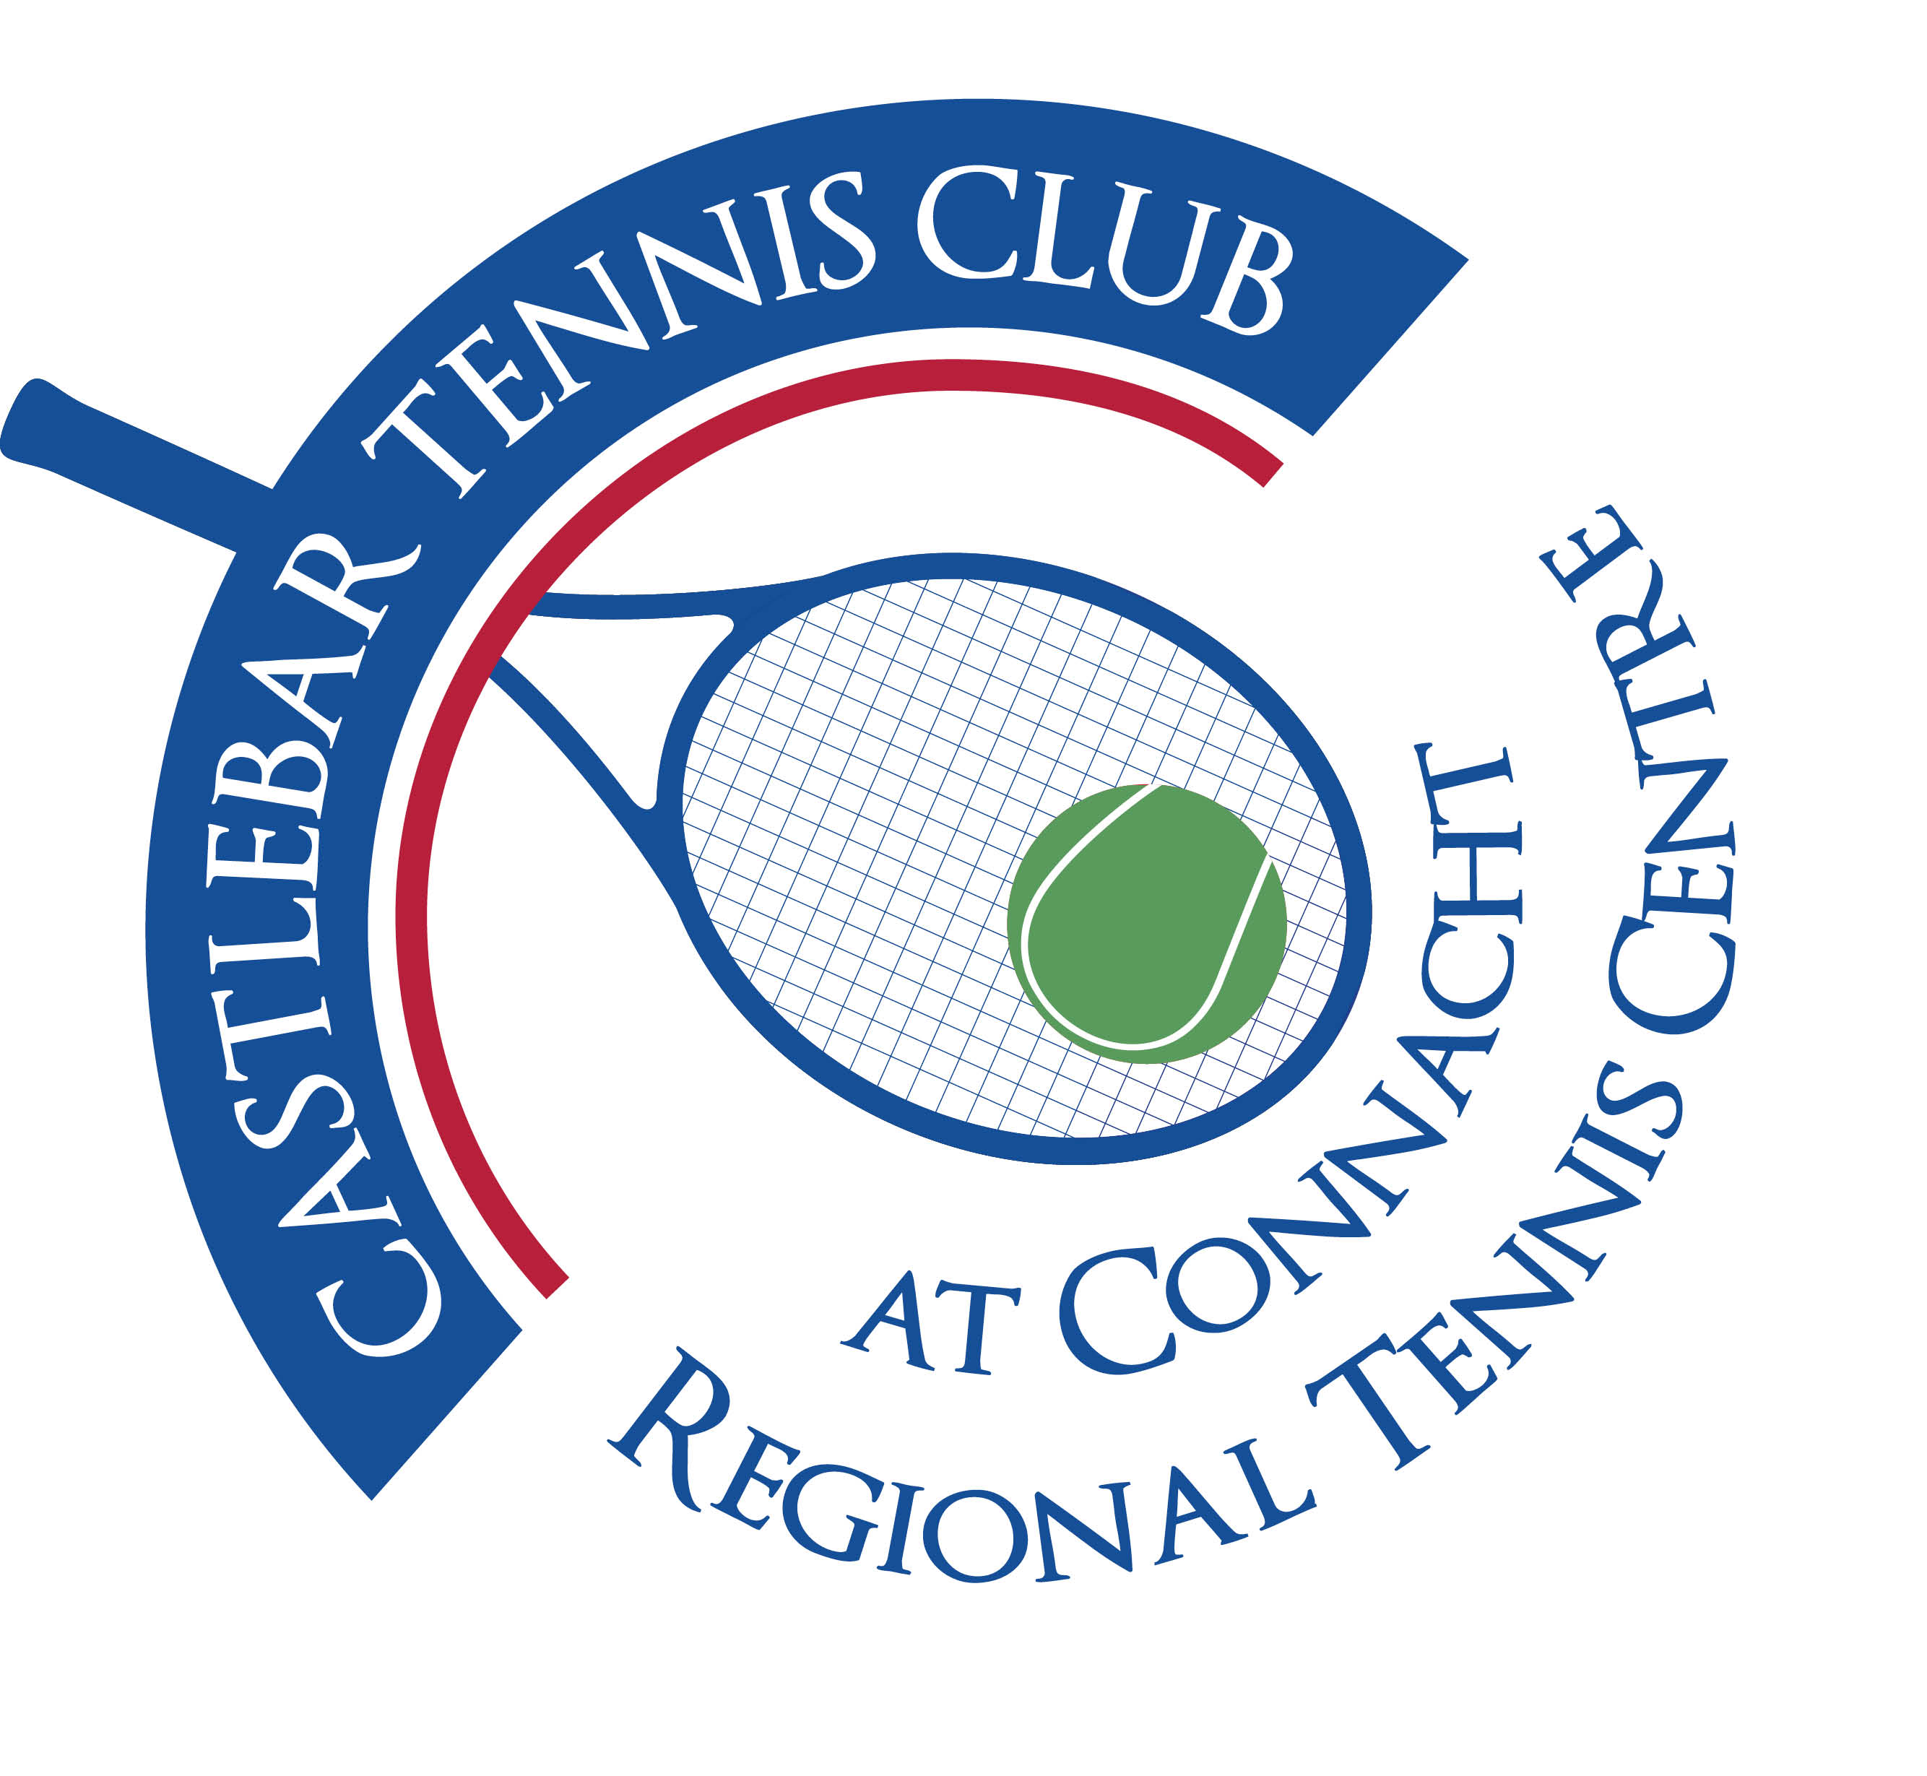

**Castlebar Tennis Club**

**AGM MINUTES**

**Monday 16th of January 2023**

**--------------------------------------------------------------------------------------------------------------------------**

**Present:** Diarmuid Gavin, Noreen McNamee, Katrina Conlon, Pat Conlon, Donal Coleman, Margaret Glancy, Erika Patzer, Dean Patzer, John O’Malley, Anne O’Malley, Monica Doyle, Kevin Durcan, John Feerick, Niamh Kilroy, Alma Egan, Tony Mannion, Garrett Barry, Neil Ferriter, Patrick Quinn, Emer Dunne. **Remotely:** Susan Carney, Sue Baird, Jo Kearney, Keith McDermott, Diane Kellett

1. **Review & adoption of AGM minutes 2022-**  Proposed by Anne O’Malley

* Seconded by Gráinne Cashin

1. **Chairperson’s Report – Diarmuid Gavin**

* The great spirit of our club was very evident in the days painting when there was a facelift given to the inside of the clubhouse and the dome up and down days.
* Tributes were paid to past club members Dave McHale, Fiona Murphy, Pauline O’Donoghue, Doc, Jerry King, George O’Malley, Conor McHale, Donie O’Brien, Dr. Irene O’Kane.
* With our new court surfaces and serviced dome we are a shining beacon for tennis in the West of Ireland. This was possible due to the €110k we received through The Sports Capital Grant. Thanks to Angela Martinez, Noreen McNamee, Dan, John O’Malley, Neil Ferriter and Bernie Caulfield for their hard work on the application for this.
* Thanks also to our Court Surface Group of Neil, Brendan, Noreen and Donie. They put a lot of work into researching the project and oversaw it’s completion in a timely fashion.
* Special thanks to club member Mohammed Al-Shatti who single-handedly removed the old plastic outer layer of the dome and brought it up from the courts to the carpark to be taken away and recycled!
* Thanks to Dan for all the work he did for the club last year. We really hoped that he would return but alas it wasn’t to be and this left a big void. He is now very happy in the Cayman Islands heavily involved in pickleball!
* Thanks to Emer for her help with coaching, all her minute-taking, keeping vending machine stocked, etc! Also to Gráinne and Freya for their work in PRO. To John O’Malley for his work in the maintenance department and to John Phillips for the work he has done around the club (painting, tidying the place up, fixing broken appliances!,etc)
* Thanks to the coaching team: Garrett, Jan, Tim, Olwyn, Caimin and Seamie for their work in the area of coaching
* Thanks to out-going captains Paul Meldrum and Alma Egan. They served an extended term of 2 years and did a super job organising tennis events and attracting lots of new members.
* Thanks to Bernie Caulfield for all her years served on the Committee. Bernie is stepping away from the committee this year. She has been (and hopefully will continue to be) a great source of wisdom around the club, always doing things in the background.
* Thanks to John Greenan for his help with lodgements and finances
* **Energy:** Our bills going up. We have changed every light to LED. Dome is the big factor in running up our bill. Usually 16k a year, we estimate it will be 50K this year! Government announced scheme starting in February, we hope to benefit from this and obtain 10% of our energy costs from them.
* We’re in deficit for our court/dome work of 20k.
* We need to get : (a)Membership numbers up

(b)Ticket sales for our draw moving

* Everyone has to sell at least 20 tickets to family/friends (need to sell **3850 more tickets** to reach our target).
* New membership fees needed because: (a) of the rising energy costs (see above)

(b) our current system is too admin heavy. We need a more streamlined system which makes it easier to join and book courts.

1. **Treasurer’s Report – Neil Ferriter**

Neil gave a broad overview of the club’s income in these main areas:

1. Membership –€ 31,708
2. Coaching- €27,021
3. Auxiliary tennis(booking fees, light tokens tournaments, etc) - €20,710
4. Hall rental/ fundraising /Grants - €19,771
5. Bar and vending machine - €7,156

Overall the figures for 2022 show - Income of €129,903

Expenditure of €133,153

Net Deficit of € 3,250

* Energy – Noreen suggested trying Pinergy (very good rates)
* Temporary Energy Scheme-may be more for trade as opposed to somewhere used by members, but will look into applying anyway
* €237k left on mortgage so 4/5 years left (€36k per annum)

1. **Coaching Report – Garrett Barry**

* Olwyn and Garrett joining forces to get things going now seeing as Dan is gone.
* Olwyn has lots of experience especially in schools tennis, inclusion.
* Garrett is now based back in Castlebar TC both coaching and also heading the coaching programme (for both Adults and Juniors) with Olwyn.
* The coaching team is completed by Jan Frydrych, Tim Clarke and Caimin Murphy.
* Sept-Xmas 2022 – well done to Alma & Paul in getting new members in. Now the hope is to build on that.

**Going Forward:**

**Adult Tennis:** Increase adult coaching and especially competitions, player assessments, WTN, ladders/leagues (after Connacht League has finished)

**Junior Tennis:** Schools tennis with blitzes (Olwyn will drive this, with funding so doesn’t cost the club), competitions for both recreational and squad groups, tennis camps at Easter, Summer Parks Tennis at St. Joseph’s school.

In addition: €3.5K grant for Enjoy Tennis, Access tennis

1. **Election of officers.**

Noreen lead the group in a thank you to Diarmuid for all the work he has done for the club over the years.

**(i)President Nominee: Paul Gavin**

Proposed by: Donie Coleman

Seconded by:Katrina Conlon

**(ii) Chairperson Nominee: Patrick Quinn**

Proposed by: Diarmuid Gavin

Seconded by: John O’Malley

**(iii)Vice-chairperson Nominee: To be co-opted later.**

Proposed by:

Seconded by:

**(iv) Secretary Nominee: Emer Dunne**

Proposed by: Diarmuid Gavin

Seconded by: Anne O’Malley

**(v) Treasurer Nominee: Neil Ferriter**

Proposed by: Katrina Conlon

Seconded by: Tony Mannion

**(vi) Men’s Captain Nominee: Tony Mannion**

Proposed by: Alma Egan

Seconded by: John O’Malley

**(vii) Ladies Captain Nominee: Niamh Kilroy**

Proposed by: Alma Egan

Seconded by: Grainne Cashin

**(viii) Committee members** :

**Nominee: Grainne Cashin-** Proposed by: Diarmuid Gavin Seconded by: Noreen McNamee

**Nominee: Alma Egan-** Proposed by: Grainne Cashin Seconded by: Anne O’Malley

**Nominee: John O’Malley-** Proposed by: Anne O’Malley Seconded by: Diarmuid Gavin

**Nominee: James Durkan:** Proposed by: Pat Conlon Seconded By: Tony Mannion

**Nominee: John Feerick –** Proposed by: Tony Mannion Seconded by: Pat Conlon

**Nominee: Kevin Durcan –** Proposed by: Diarmuid Gavin Seconded by: Garrett Barry

**Nominee: Dean Patzer** – Proposed by: Diarmuid Gavin Seconded by: Patrick Quinn

**Patrick Quinn-presentation on New Membership Fee Proposal –**

**Comparisons and Benefits** (See email sent to all members on Friday 20th Jan 2023)

**Proposed timeline: Jan 1st – Jan 31st** (free month membership to members)

**1st – 15th Feb** – Members will be asked to register for new system(video to assist with this)

**20th Jan – 28th Feb** – engineers getting lighting system changed

**March 1st –** new system with new lighting fully functional

1. **Q & A –Discussion**

**Q.** Questions arose over possibility of people opting out of membership for some months – how will club cover costs if this happens?

**A.** Lower monthly fee of €50pm if members sign up for 12 months (increased rate of €80pm for 3 months/€100pm for 1 month). People can apply for a pause to their membership for a valid reason ie illness (to be decided by committee)

**Q.** What if people book & don’t turn up? (less of an incentive to cancel a court under new system)

**A.** This will be monitored. When a court is cancelled, an email will go out to alert members who can then book the court

**Q.** Monitoring of non-members playing?

**A.** Plan is to automate all doors and prevent access to dome if you’re not a member(access will be via phone app)

**Q.** Any other club using this proposed new system?

**A.** Yes clubs in Dublin and it’s working very well

**Q.** Will we have a review after a few months to see if the new system is working well & covering all the bills?

**A.** It was suggested to review the new system (if adopted) after 6 months to see if costs were being covered.

**Q.** Is the rent for the hall increasing?

**A.** Yes it is, Paul already has an increase in place.

**Q.** The new figures reference tennis only. We need to emphasise the social side of things in the club again

**A.** We need a social committee to work with the captains – attract new members – more activity and spending at the bar. Suggestion: have Sundays as a social day, have an event/bbq, everyone brings something, you don’t feel the club is yours unless you socialise here.

-It was decided that an EGM would be held on Monday 23rd January( update: this was changed to Thursday 26th January at 7.30pm) to vote on the new membership fee structure. Information on same (comparisons and benefits of new system) would be emailed out to members, allowing time to digest it before the EGM.

1. **AOB**

-Sue Baird offered to help update the Club’s Constitution.

**____________________________**

**Emer Dunne**

**Hon. Secretary**